Module 5

Understanding and Developing Listening in a Foreign Language

This module is divided into the following sections:

Outcomes

Author of this module

5.0 Introduction

5.1 Understanding understanding: a theory of listening
5.1.1 Listening and second language acquisition
5.1.2 What do we mean by comprehension?
5.1.3 Definitions of aural comprehension
5.1.4 Levels of comprehension
5.1.4.1 Bottom up and top down processes
5.1.4.2 Exploring challenges to comprehension
5.1.5 Schema theory
5.1.5.1 Formal and content schemas
5.1.5.2 Exploring the role of schematic knowledge
5.1.6 The challenges for L2 listeners
5.1.6.1 The strategies of effective and ineffective listeners
5.1.6.2 Less proficient listeners at advanced level

5.2 Features of aural input
5.2.1 Reciprocal and non-reciprocal listening
5.2.1.1 Ideas for reciprocal listening tasks
5.2.2 Judging ease and difficulty of aural input
5.2.2.1 Density and complexity of content
5.2.2.2 Speed of delivery
5.2.2.3 Familiarity with the topic
5.2.2.4 Predictability of content and structure
5.2.3 Using video
5.2.3.1 Key techniques for using video recordings
5.2.3.2 Using subtitles
5.2.4 Authentic or scripted materials?

5.3 Developing listening activities
5.3.1 Tasks for top-down processes
5.3.2 Tasks for bottom-up processes
5.3.3 A cycle of listening activities to support comprehension

5.4 Choosing technologies for supporting audio and video work
5.4.1 Analogue technologies
5.4.1.1 Classroom use
5.4.1.2 Learner-controlled listening
5.4.2 Digital technologies

5.5 Commentary on reflective tasks

5.6 Appendices

5.7 References
5.8 Recommended further reading

5.9 Assessment task

Learning outcomes

At the end of this module, you should be able to:

- show you understand the challenges of listening comprehension for foreign language learners and how these can be addressed in materials design;

- identify how different comprehension activities can be used at different stages of the comprehension process;

- evaluate and select comprehension activities to exploit audio and video input.

Author of this module

Elspeth Broady is Principal Lecturer in the School of Languages, University of Brighton. With initial training as a teacher of French and EFL, she now teaches Second Language Acquisition, Psycholinguistics and Materials Design on undergraduate and postgraduate language teacher education courses. She has produced several textbooks, videos and CD-ROMS for language learners, and has worked as a consultant for BBC and Open University language courses. Her teacher education projects include work on video, ICT and learner autonomy for the Council of Europe and Tempus programmes. Her research interests are in the area of learning strategies, learner autonomy and learners' use of explicit grammatical knowledge.

5.0 Introduction

The aims of this module are to help you:

- understand what is involved in listening comprehension;
- establish why listening is important in language learning;
- become aware of the range of listening materials and tasks for language learning and develop skills for selection of materials;
- understand the potential offered by video recordings;
- establish principles for designing and modifying listening and viewing activities for language learning;
- extend your understanding of how different technologies can be used to achieve different purposes in promoting second language (L2) listening skills.

5.1 Understanding understanding: a theory of listening
In this first section, we explore the role of comprehension in second language acquisition and the kinds of skill and knowledge that understanding requires.

5.1.1 Listening and Second Language Acquisition
5.1.2 What do we mean by comprehension?
5.1.3 Definitions of aural comprehension
5.1.4 Levels of comprehension
5.1.5 Schema theory
5.1.6 The challenges for L2 listeners

Below is a summary of the theory of listening that will be developed in this section:

- In second language learning, listening comprehension needs to be addressed both as a skill in its own right (learning to listen) and also as a means by which new language is processed and retained (listening to learn).
- Spoken language is typically different from written language because it usually has to be processed sequentially and in real time by both speakers and listeners. Written language generally provides more clues to the grammatical status of words, e.g. in French, allez, allé, aller, allaient, allait are written differently but to the hearer, they will all sound the same (or very similar). Listening is thus subject to more severe processing constraints than reading.

- Listening comprehension is a multilayered skill involving bottom-up processes and top-down processes.

- Successful comprehension relies on an integration of bottom-up and top-down processes.

- Listening comprehension relies on both knowledge of language and knowledge of the world.

5.1.1 Listening and second language acquisition

All you have to do is understand, and the second language will grow by itself. Or will it??

Listening is fundamental to second language learning; indeed, it is probably the most important skill underlying the development of a second language.
One of the most influential recent models of second language acquisition has been Steven Krashen's (1985) Input Model. This claims that second language acquisition is driven by learners' attempts to make sense of language which is addressed to them. Once learners start to understand target language ‘input’, Krashen claims that they will automatically pick up the grammar. All that is necessary is meaningful or comprehensible input: there is no need to learn grammar rules explicitly.
But how do learners make input comprehensible if they don’t already have a knowledge of the grammar and vocabulary? Krashen argues that learners use their knowledge of the world to guess at the meaning; furthermore, he claims, speakers automatically simplify their language in order to get their message across to learners.
Few researchers would disagree that extensive exposure to meaningful target language is essential in second language development. Written texts can of course provide comprehensible input, but if a learner is going to speak the target language, then spoken input is essential. Many teachers and researchers have nevertheless challenged Krashen's assumption that 'all you have to do is understand, and the linguistic system will take care of itself'. While comprehensible input may be essential, it may not be sufficient to ensure second language development to high levels of accuracy and complexity.
Van Patten (1989), Schmidt (1990) and Skehan (1998) have all argued that when adults try to understand L2 input, they focus on the content of what is being said, noticing vocabulary items. They may pay some attention to obvious grammatical features such as word order, but many grammatical features such as determiners and word endings are often not noticed, simply because the listener can usually work out the meaning without them.
It seems unlikely that the average adult learner will be able to pay attention to both meaning and form in the target language at the same time. The above authors have claimed that learners' attention needs to be drawn to grammatical features of input after it has been comprehended. In other words, it is not enough to learn to listen (ie just make sense of the target language input); learners also need to listen in order to learn (ie pay attention to the linguistic features of the text in order to retain them). 'Just understanding' is not enough...

5.1.2 What do we mean by comprehension?

Reflection task 1

Click here to hear a short statement. [LINK TO CD]

To what extent would you say you understood it?

If you felt you had problems understanding it, what hindered your understanding?

Refer to Commentary for feedback.

Now let’s imagine, difficult though it may be, that a version of the above extract is said by a university lecturer in the context of a discussion:
A. You see, the conventional approach to testing treats processing and contexts as things to be handled by extension, once the underlying pattern of abilities has been measured ... while, in contrast, a processing approach - which is what my model’s about - will regard the capacity to handle real language use as the dominant factor ...

We can then imagine a whole range of responses to this:

B. Huh? What ARE you on about?...You’re on holiday, remember, so you can stop lecturing me!

C. What mean ‘venshunulprosh’?

D. OK, so what you’re saying is that the ability to process language in real time is the key in testing? But how then do you account for lexical knowledge in your model?

E. Hmm ..first treat processing context, extension once and then measure as pattern ability???

F. Er yes ... of course.The conventional approach versus the processing approach... Mmm ... interesting

Reflection task 2

Study the five different responses above.

1 In your view, which response reflects the most comprehension?
2 Which response reflects the least?
3 Rank all the responses in order of comprehension.
4 As a result of doing this task, how would you define comprehension?

Refer to Commentary.

5.1.3 Definitions of aural comprehension
Here are two definitions of comprehension from teacher-researchers:

Comprehension is the process of relating language to concepts in one's memory and to references in the real world. Comprehension is the sense of understanding what the language used refers to in one's own experience or in the outside world. Complete comprehension then refers to the listener having a clear concept in memory for every referent used by the speaker.
(Rost, 2002: 59)

Comprehension is not understanding what words mean, but is understanding what speakers mean. Even after getting the meaning of the words, the listener must still try to understand what speakers mean.
(Buck, 1999)

Both of these definitions imply that comprehension takes place when language links to our knowledge of the world. The idea is that through language, the listener is able to access the concepts and references which are in the speaker's mind.
However, that correspondence is never total. Words are not used to communicate meaning on their own, but in context with other words, which influence their meaning. Moreoever, speakers often do not explicitly communicate information which they assume is shared with the listener.
Much comprehension, therefore, is based on inference, with the listener filling in, interpreting what the speaker must mean. It is in this sense that the second definition stresses that comprehension is 'understanding what speakers mean'.
Usually before listeners can make inferences about the speaker's meaning, they have to make some sense of the raw material, ie the stream of sound. But even here, we use our background knowledge of the language system and of the world in order to 'fill in' partial information.
Comprehension then requires the integration of different levels of skill and different kinds of knowledge.

5.1.4 Levels of comprehension

BOTTOM | Level 1 Sounds to words  What are the patterns of meaningful sound?  At this level, speech sounds are perceived, categorized and retained in some kind of organized string.  What are the words being said?  The perceived sounds are segmented into 'units', which then have to be recognized as words.
Level 2 Words to basic meaning

What do these 'words' mean?

Lexical meanings are accessed for the 'words' (semantic processing), the grammatical cues, eg word order, endings, may be processed (syntactic processing) and the listener tries to arrive at a basic sentence meaning or proposition.

TOP | Level 3 Meaning to intention  What is the speaker really trying to say?  At the intention level, the listener tries to map the different propositions into a coherent whole and understand the significance of the meanings as intended by the speaker.
Level 4 Communication level

Having understood what has been said in terms of its intention, the listener has to ask: how should I respond appropriately? For example, do I agree with what has been said: if not, how can I disagree politely?

5.1.4.1 Bottom up and top down processes
Psycholinguists refer to two types of process involved in comprehension. These processes are not independent but interact with each other:
- Bottom-up processes refer to speech perception and word recognition, ie what happens around Levels 1 and 2 when we identify units in the stream of sound and try to access their lexical meaning. These processes provide the 'data' for comprehension. (Rost, 2002: 96)
- Top-down processes involve interpretation of the 'data', based on our knowledge of the world, for example, when we predict the words we think we will hear from our knowledge of context, or interpret a statement based on our social expectations.
The terms ‘bottom-up’ and ‘top-down’ imply dynamic processes. In comprehension, we are constantly moving from the data we perceive to finding an interpretation for it, while simultaneously using our interpretations to predict data we expect to meet.

In second language learning, top-down strategies, such as guesswork from background knowledge, can be very useful since they can compensate for restricted linguistic knowledge. However, they are insufficient on their own for effective comprehension.
Bottom-up skills are also inadequate on their own since they may prevent the listener from keeping up with the stream of speech. We may need to miss out some of the bottom-up processes in order to process speech quickly in real time, particularly under difficult conditions.
To compensate we can rely on top-down processes of guess-work and inference. However, fluent and effective listening still requires us to monitor the bottom levels in the background. This is a particular difficulty for second language learners who, by definition, require longer to process the incoming sounds. Learning to combine the two types of processing is a real challenge for learners.

5.1.4.2 Exploring challenges to comprehension
Reflection tasks 3 and 4 below are designed to help you become aware of the different levels of comprehension and how different levels interact.

Reflection task 3

1 Click here to hear a phrase in a foreign language. After two listenings, try to write down the words that you hear. [LINK TO CD]

2 Click here to see a written representation of the stream of sound. Compare with your notes and note as many 'words' as you can. [see Commentary 3a]

3 Click here for some idea of the context [see Commentary 3b]

4 Can you guess what the phrase means?

5 Can you identify any further 'words'?

6 What knowledge are you using to segment the stream of sound?

Now refer to Commentary 3c.

Reflection task 4

Imagine you are at a party where there's a fair amount of background noise. You start to tune into the conversation going on next to you. You hear the following:

blah blah blah my colleague blah attacked blah his neighbour blah blah tennis racket blah blah blah seriously injured blah blah in blah hospital

Before reading any further, write out in full what you think the speaker said.

Here's what probably happened when you when you did Reflection task 4:
Having identified the string of phonemes ‘a-tt-a-ck’, you would have rapidly accessed the lexical information associated with the word ‘attack’, that is, the meaning of the action and the semantic roles typically involved: an agent (an animate someone or something) attacks a patient (someone or something suffering the action). You can do this quickly, because you are a fluent user of English, but of course, it is much for difficult for language learners whose vocabulary knowledge may be limited.
Having accessed ‘attack’, you then searched the other words you had retained (for fleeting microseconds, in short-term memory) for the agent (usually the subject) and the patient (usually the object). The verb ‘attack’ may also be associated with information about the instrument used, the time, the place and the result of the attack.
As we identify a word in the stream of sound, so we make predictions about the possible semantic roles it might play.That in turn helps us to identify other words and fit a coherent proposition around them. Again, we draw on our knowledge of the world to do this quickly: for example, ‘tennis rackets’ are more likely to play the role of instrument than the role of patient of the verb ‘attack’.
Thus, on the basis of your lexical processing so far, you probably arrived at something like the following proposition:

My colleague attacked his neighbour with a tennis racket. He (the neighbour) was seriously injured and is still in hospital ...

So far so good ... But imagine you then responded on the basis of this understanding and the reaction was one of incomprehension:

So has your colleague been arrested or something?
??? What do you mean?

YOU OTHER SPEAKER

What might have gone wrong? What did you miss?

1) Grammatical cues
Now in most languages, various grammatical cues (words and parts of words) also help to confirm the assignment of semantic roles to the words in an utterance. For example, in languages such as German and Russian, there are different endings for subjects (usually, agents) and objects (patients): phrases expressing time, manner and place occur in predictable places in the utterance, or are marked with particular endings. In English and French, standard word order places the subject (usually, agents) before the verb.
Fluent listeners pay only very fleeting attention to these grammatical cues: just enough to monitor for any information which might challenge their interpretation. For less fluent listeners, or even expert listeners listening in difficult conditions such as our noisy party, this background monitoring of grammatical cues may simply be too demanding – such that miscomprehensions can occur:

Back to the party ... and what the other speaker actually said was:

My colleague WAS attacked BY his neighbour... HE USED A tennis racket TO DEFEND HIMSELF. HE WAS seriously injured. IT HAPPENED in THE hospital ...

2) Background information
Now, what you didn't know was that the speaker worked as a hospital doctor. Furthermore, the topic of conversation before you joined in had been the increasing numbers of attacks on hospital doctors.
The idea that the attack happened in a hospital probably did not occur to you: you probably made the obvious connection between 'seriously injured' and 'ending up in hospital (as a patient)'. But had you been aware of the context in which the incident was being recounted, you probably would have interpreted ‘hospital’ correctly.

Another point which might have led you to reject your original interpretation is that we generally prioritize the things which are closest to us. Thus, if ‘my colleague’ had been the attacker, it would have been more natural to talk about what had happened to him, rather than what had happened to the neighbour.

In both Reflection tasks 3 and 4, we can see how we mobilize our knowledge of language and our knowledge of the world to help us arrive as quickly as possible at the intentional level of comprehension – at the main point of what the speaker is trying to say. We don't always get it right! This reminds us of just how demanding listening can sometimes be for second language learners.

5.1.5 Schema theory
In order to explain how we draw on our existing knowledge in comprehension, cognitive psychologists such as Bartlett (1932) have come up with the term schema. Schemas (or schemata) are simply frameworks of concepts stored in long-term memory which represent our current understanding of the world. They are constantly being updated as our knowledge and experience changes.
For example, relating back to our earlier example, your schema for the word ‘hospital’ probably associates it with a place where you go with serious injury or disease. However, after a conversation with hospital staff, or after hearing repeated reports of violence in hospitals in the news media, you may add to your hospital schema the idea that they are places where staff get attacked!
The process of comprehension, then, relies on our matching the input we hear to existing schemas. Schemas determine our expectations and provide the context for interpreting linguistic information quickly and efficiently. They obviate the need for listeners to process every word spoken before getting the essential meaning. They relieve speakers of the need to state details which may plausibly be assumed to be shared by the listener.
Of course, as we comprehend, we may notice new information in written or spoken input, and modify our schema as a result. However, comprehension simply breaks down when we cannot link incoming linguistic information to an existing schema, or if we have selected the wrong schema for its interpretation.

5.1.5.1 Formal and content schemas
Schemas relate both to content, that is, our expectations about how things are in the world, and form, that is, our expectations about the organization and structure of a particular type of discourse.
The role of both content and formal schemata has been established in both L1 and L2 comprehension (Long, 1990: 66–8). The problem in L2 comprehension is two-fold:
- learners do not always mobilize their existing schemas in L2 comprehension;
- existing schemas are inevitably determined by one's cultural background, and therefore may be insufficient for interpreting L2 input.

Reflection task 5

All of the questions below draw on your content or formal schemas. Answer the question and identify whether you think the schematic knowledge you are drawing on is formal or content (or both).

1 If I tell you you are going to hear a news bulletin about a strike, what kind of information would you expect to hear?

2 If you bump into a friend at the bus stop, what kind of thing do you expect them to say first?

3 If you listen to a lecture, what kind of information do you expect in the first few minutes? in the last few minutes?

4 What information do you expect to hear in loud-speaker announcements in a railway station?

5 You decide to watch a TV documentary about trains in Britain. What issues do you expect to come up?

6 What information do you expect to hear at the end of a news bulletin (before the weather forecast)?

Now refer to Commentary.

5.1.5.2 Exploring the role of schematic knowledge
The following examples illustrate how phonological and lexical differences between North American and European usage, together with different schemas, caused comprehension breakdowns for an otherwise proficient listener. Imagine how much more difficult things get for less proficient listeners!

Example 1
Example 2
Example 3

Example 1

Context Road-side café in North America

Participants A: Woman working at the serving counter

B: British tourist

Situation The British tourist has ordered two coffees.

A To go (t@gO)?

B Er .. With milk but no sugar

A You want them to go (t@gO)?

B I'm sorry .. could you say that again?

A To go (t@gO)?

B ???

A Are you drinking them here?

B Er, yes.

A OK, that's 1$95

Here the initial problem was an unfamiliar lexical phrase ('to go' rather than 'to take away?'), further complicated by unfamiliar pronunciation (t@gO, not t@g@U). This meant that the tourist could not arrive quickly at a clear idea of the words being uttered. Her existing schematic knowledge couldn't help either: for the British tourist, it was not customary to buy a coffee to 'take away' in a café where there was seating. This, however, was customary in North American roadside cafés.

Example 2

Context Airport car rental desk in French-speaking Canada

Participants A: French-Canadian rental clerk

B: British tourist with fluent command of French French

Situation Having completed formalities for car rental (in French), the British tourist asks for directions to her ski-ing resort.

A Vous prenez le quinze nord (naR)

B D'accord (notes down) le quinze ... Narre, ça s'écrit comment?

A Comment?

B La ville, Narre, comment ça s'écrit? N-A-R-R-E?

A Mais ???... c'est 'nord' comme 'sud'. Le quinze nord ...

B Ah d'accord, nord (nOR).N-O-R-D... merci Madame, le quinze, direction nord

In this example, unfamiliar pronunciation (naR rather than nOR) again caused the initial problem, but schematic expectations reinforced it. The British tourist expected directions to contain reference to a road number and a town (eg 'take the A27 to Lewes'). North American directions generally refer to a road number and its cardinal direction (‘take Highway 46 East’).

Translation:

A You take the fifteen North (naR)

B OK (notes down) the fifteen ... Narre, (naR) how do you spell that?

A Sorry?

B The town, Narre, how do you spell it? N-A-R-R-E?

A But ???.... it’s North, like South. The fifteen North...

B Ah OK, North (nOR).N-O-R-T-H...Thanks, the fifteen, direction North.

Example 3

Context Plane journey, American crew

Participants A: American flight attendant

B: British passenger

Situation The flight attendant is serving coffee to the passenger

A Would you like cream and sugar (kri:mS3) with your coffee?

B (Hears 'Would you like ‘creatures’ in your coffee?') Sorry?

A Would you like cream and sugar with your coffee?

B (Again, hears 'creatures'. Cannot possibly be right). I'm sorry?

A Cream ... in your coffee, Ma'm? (holds up a milk jug)

B Oh, milk ... yes please.

A Sugar?

B Er ... No thanks

Here, the passenger was expecting to be asked about 'milk and sugar', so ‘cream’ was a slightly unexpected lexical item. Then the pronunciation of suga' was unfamiliar (S3 rather than SUg@) and further, it was elided into kri;mS3. Thus the

word she fitted against the sound stream was 'creature', which of course, she then couldn't fit into any existing schema of 'having coffee'. Comprehension broke down until the flight attendant segmented her phrase differently. Here the bottom level processing (from sound stream to lexical item) blocked out top-down processing (predicting 'cream' as a possible word from knowledge of the situation).

5.1.6 The challenges for L2 listeners
We have established that effective listening comprehension involves integrating different levels of processing and mobilizing different types of knowledge.
Problems are often faced by second language learners either because of weaknesses at a particular level or because of their inability to integrate these different levels of processing sufficiently.
There seem to be two problematic approaches:

Bottom-up learners
Some learners seem to have problems in using top-down prediction skills in order to alleviate the load on their bottom-up processing (ie in identifying words quickly in the stream of sound). They have problems 'filling in' missing knowledge through intelligent guess-work. These are the learners who tend to feel that their task is to listen and note down every word.

Top-down learners
Many learners have developed very effective top-down prediction skills, but this may in fact cause them to neglect their bottom-up processing, and thus miss potentially important information. These are learners who 'guess' everything, but don't in fact listen carefully.

5.1.6.1 The strategies of effective and ineffective L2 listeners
Various studies have looked at the approaches taken by ineffective and effective L2 listeners.
O'Malley et al (1989) asked intermediate Spanish-speaking high school students enrolled in English as a Second Language classes to 'think aloud' at various stages in completing listening comprehension tasks. The reports of students classified by their teachers as effective and ineffective listeners were compared. The following differences were highlighted:

Effective listeners | Ineffective listeners
Use intonation and pauses to help 'parse' what is being said
Focus on phrases or sentences, but shift attention to words when there seems to be a breakdown in comprehension | Focus on individual words
Don't allow unknown words to divert their attention from the continuing stream: trust that they will be able to 'get something' | Get easily diverted and disheartened. Get lost in the stream of sound.
Actively make connections between what they hear and what they already know; try to elaborate on the elements understood in order to arrive at a plausible understanding
Ask questions about what they have understood in order to try to fill in missing information

It seems, from this research, that effective listeners are more able to integrate bottom-up and top-down processing than ineffective listeners. It is difficult to know, however, whether ineffective listeners have problems because they don't mobilize their existing knowledge sufficiently well or whether their bottom-up processing may be impaired by restricted language knowledge, ie they simply can't 'catch' enough language in order to mobilize top-down processing.
The truth is likely to be in between these two hypotheses. Certainly, there is a danger for weaker listeners that poor word recognition skills will lead to inability to mobilize any existing knowledge, which in turn will lead to a sense of 'being lost', which will lead to demotivation and a reluctance to attempt any compensatory guess-work at all.

5.1.6.2 Less proficient listeners at advanced level
Particularly at more advanced levels, less effective listeners may also be those who rely too much on top-down processing and devote too little attention to checking their interpretations against all the information.
In what follows, you can explore how two first year post A-level students of French coped with understanding a complex seven-minute interview in French. This was part of a listening comprehension exam and their task was to write a summary of the interview in English.

Reflection task 6

Study the extract from the interview and then look at Student 1's answer. What difficulty has she had in completing the task? What strategy did she use?

Source: an authentic interview with Catherine Clément (in Dominique et al, Sans Frontières 3, Clé International, 1984: 182–83), who explains her job at the head of an association promoting international cultural exchanges:

Je suis tout à fait d'accord avec l'expression d'importation et d'exportation (1). Je veux dire que la transposition marchande de la réciprocité est une chose importante ... car de même qu'on parle du commerce des idées qui veut simplement dire la conversation ou l'échange des idées philosophiques .. et bien de même il y a le commerce des arts ... et le mot commerce (2) est à prendre dans tous les sens et le sens financier (3) est très important (4).

I totally agree with the expressions 'import' and 'export' (being used in relation to culture). What I mean is that the commercial dimension of reciprocal arrangements is something which is important ... just as we can talk about the exchange (commerce) of ideas, which simply means conversation or the exchange of philosophical ideas, so in the same way, there is exchange of art ... and the word 'commerce (exchange)' should be understood in its range of meanings, and the business (financial) meaning is very important.

Student 1's answer:
Catherine Clément does not like the expressions 'importation' and 'exportation' (1) when it comes to French culture, though she sees that French business (2) is very important (4) to culture as they give financial support (3).

Refer to Commentary for feedback.

Reflection task 7

Again, study the extract from the interview below and then look at the Student 2's answer. What difficulty did he have in completing the task? What strategy did he use? Were the difficulties encountered and the strategy the same as in the previous case (Reflection task 6)?

Source: an authentic interview with Catherine Clément (in Dominique et al, Sans Frontières 3, by Clé International, 1984: 182–83), who explains her job at the head of an association promoting international cultural exchanges:

Les buts initiaux de cette association qui a été créée en 1922 (1)... étaient texutellement l'expansion de la culture française à l'étranger, je souligne le mot expansion parce qu'en 1922, on ne pouvait difficilement penser autrement, c'était la pleine époque du colonialisme (2), c'était disons le sommet de tous les empires coloniaux des pays occidentaux, pas seulement la France d'ailleurs, et ce mot d'expansion n'a plus de sens maintenant, puisque ce qui se pratique entre pays à l'échelle internationale s'appelle maintenant pas le beau mot de réciprocité ... ce qui est tout à fait différent. C'était l'époque où on envoyait deux ou trois grandes tournées de théatre (3) que les pays étaient censés accueillir comme l'essence meme de la France ... il est bien évident qu'on n'en est plus du tout là. On sait que toutes les cultures sont égales, toutes aussi riches les unes que les autres ... (4)

The initial aims of this association, which was set up in 1922 ... were quite specifically the expansion of French culture abroad. I'm deliberately emphasizing the word expansion because in 1922, that was how people thought, it was the big era of colonialism, it was the high point of the colonial empires of the Western countries, and not just France ... and that word expansion now is no longer relevant, because what happens now between countries at an international level goes by the grand term of 'reciprocity' ... which is completely different. That was the time when we used to send our two or three theatre tours which those countries were supposed to accept as representing the very essence of France and things French ... of course, it's quite clear we're no longer there. We consider that all cultures are equal, each as rich as each other ...

Student 2's response:
The AFAA was set up in 1922 at a time when France was being colonised. In this era, French theatre was very successful. It seemed that all cultures around the world were equally good and as rich.

Click on Commentary.

5.2 Features of aural input
In this section, we review some of the key considerations you need to keep in mind in selecting listening inputs to use in second language teaching.

5.2.1 Reciprocal and non-reciprocal listening
5.2.2 Judging ease and difficulty of aural input
5.2.3 Using video
5.2.4 Authenticity or scripted materials?

5.2.1 Reciprocal and non-reciprocal listening
As natural users of any language, much of our listening will be reciprocal, that is, part of conversational interaction where we can see, or at least, engage with the speaker. In many ways, reciprocal listening is easier for the listener to control than non-reciprocal listening. If we fail to understand our interlocutor, we can indicate our lack of understanding, which generally triggers some kind of clarification from the speaker, be it in the form of repetition or reformulation.
Many of the the listening resources offered in contemporary coursebooks for foreign language learning almost exclusively involve non-reciprocal listening, that is, where the learner is placed in the situation of eavesdropper or audience, with little possibility for direct intervention in the discourse. In non-reciprocal situations, then, the learner's comprehension has to be mediated through pedagogical tasks and activities

Reflection task 8

When as a listener you experience a break down in communication in a language that you use proficiently (eg you haven't understood something a speaker has said to you, or you think you might have misunderstood), what do you do? Do you do the same thing in languages you are not so proficient in?

When as a speaker you realize your interlocutor may not be following what you've said, particularly when you are using a language your interlocutor is not proficient in, what do you do?

5.2.1.1 Ideas for reciprocal listening tasks

Conversational management strategies
First, get students to listen to a conversation where comprehension breaks down (eg En route vers l'Europe, 4, dialogue 2, Section 5.6, Appendix 1). Get them to identify how the speaker and listener dealt with the breakdown. Identify key phrases for dealing with communication difficulties, as in the example below.

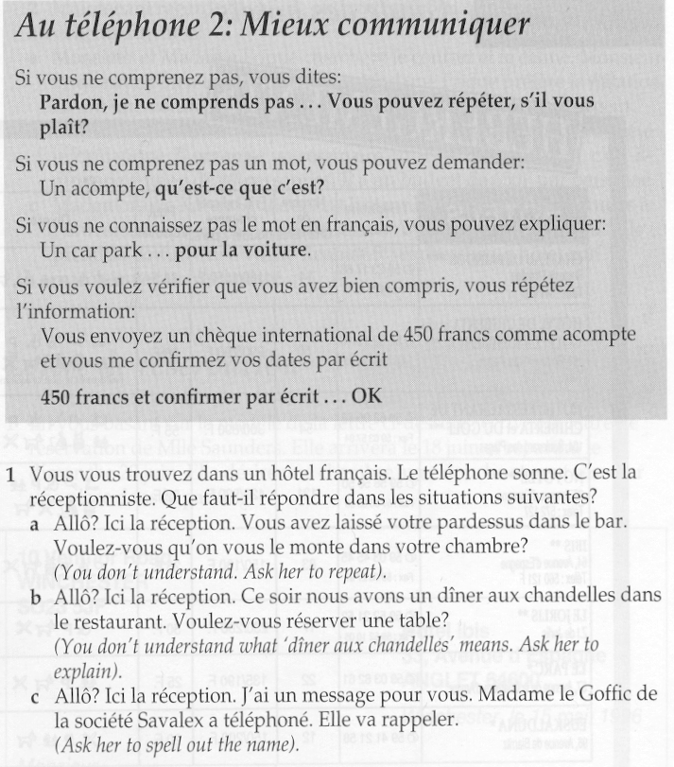

Extract from En route vers l’Europe by Elspeth Broady and Catrine Carpenter, © Hodder and Stoughton, 1996

English Translation Telephoning skills 2: Communicating better

If you don’t understand, you can say:
I’m sorry, I didn’t understand ... Could you repeat that, please?

If you don’t understand a particular word, you can say:
What’s ‘a deposit’?

If you don’t know the word in French, you can try to explain:
A ‘car park’ ... for the car.

If you want to check that you’ve understood, you can repeat the information:
So you need to send an international cheque for 450 francs as a deposit and confirm your dates in writing ...
450 francs ... and confirm in writing ... OK

Exercise 1
You find yourself in a French hotel. The telephone rings. It’s reception. What would you say in the following situations?

a. Hello? It’s reception here. You’ve left your overcoat in the bar. Would you like us to bring it up to your room?
(You don’t understand. Ask the receptionist to repeat)

b. Hello? It’s reception here. This evening, we have a candlelit dinner taking place in the restaurant. Would you like to reserve a table?
(You don’t understand what a ‘candlelit dinner’ means. Ask her to explain)

c. Hello? It’s reception here. I’ve got a message for you. Madame le Goffic from Savalex ‘phoned. She’ll call back.
(Ask her to spell out the name).

Students then need to practise using these phrases in real situations, eg:
- get your students to telephone public information sources (such as Tourist Offices, etc) in the target language country to request information;
- get your students to interview you or other native speakers. Do not adjust your language too much to the level of the student (and brief other native speakers to do the same): leave the management work to the students themselves.

Class quizzes
The advantage of class quizzes is that they are motivating but also require careful listening. Depending on the level of your class and your aims, either you or your students set the questions. Write some questions that you think will stretch the listening abilities of your class.
Again, depending on the skills of your class, appoint a quiz-master or play the role yourself. Tell students they have to ask for a repeat of the question or any clarification. You – or the quiz-master – will not provide it automatically.
Get other students to judge whether the answer is correct or not. Again, they may need to ask the student answering to repeat or to clarify.

Instructions
Develop your learners' ability to understand complex instructions through various types of information-gap activities and games: for example, two students are given information about where different objects have to be placed on a map or diagram. They have to give each other instructions in order to place all objects correctly.
If you want to stretch your learners' reciprocal listening skills, you could give the instructions at normal speed in the target language. Then allow your learners the opportunity to ask you for clarification.

5.2.2 Judging ease and difficulty of aural input

Reflection task 9

What are your instinctive criteria for judging whether a listening passage is 'easy' or 'difficult' for your learners?

Note down your criteria. After you have read this section, come back and compare your ideas with those developed here.

There seem to be no hard and fast rules for distinguishing an ‘easy’ from a ‘difficult’ listening passage, since notions of ‘ease’ and ‘difficulty’ for learner will depend on
- the passage (the speakers, the language used, the structure, the content);
- the listening task;
- the learner.
For example, the task of identifying three pieces of key information, such as the date, time and place for an appointment, in a long dialogue is likely to be easier than summarizing a much shorter, but denser monologue, such as an item from a news bulletin. Listening to a recording of someone you know talking about something you know about is likely to be easier to understand, even if the speech is faster, than in a recording of someone you don't know talking about something that you know nothing about. If you have been given some idea of the possible content of a listening passage (for example, in some kind of pre-listening task), then you will find it easier to understand than without any such preparation.
Apart from opportunities for interaction, mentioned in Section 5.2.1, four factors generally contribute to comprehension ease/difficulty:
- the density and complexity of the information contained in the passage;
- the speed of delivery;
- the learner’s familiarity with the topic;
- the predictability of the content and the structure of the talk.
In what follows, we review each of these points in turn.

5.2.2.1 Density and complexity of content
Brown et al (1984) derived the following principles of conceptual difficulty in listening on the basis of empirical investigation of interactive listening tasks:

Principle 1: Texts with fewer rather than more individuals and objects are likely to be easier.

Principle 2: Texts which involve individuals and objects which are clearly distinct from one another are likely to be easier.

Principle 3: Texts (particularly instructions and descriptions) which involve simple spatial relationships are likely to be easier.

Principle 4: Texts where the order of telling matches the order of events are likely to be easier.

Principle 5: Texts where each utterance requires relatively few inferences to relate back to the preceding text are likely to be easier.

Principle 6: Texts where the information is unambiguous, consistent and fits readily with information you already have are likely to be easier.

Reflection task 10

In Section 5.1.6.2 we looked at how first-year French students coped with an interview with Catherine Clément, the Director of an association promoting cultural exchanges.

Read through the extract of the interview below and using Brown’s six principles , decide in what ways this interview might be considered 'complex'

Interviewer: What are the aims of the Association Française pour l'Action Artistique?

Catherine Clément: The initial aims of this association, which was set up in 1922 ... were quite specifically the expansion of French culture abroad. I'm deliberately emphasizing the word expansion because in 1922, that was how people thought, it was the big time of colonialism, it was the high point of the colonial empires of the Western countries, and not just France ... and that word expansion now is no longer relevant, because what happens now between countries at an international level goes by the grand term of 'reciprocity' ... which is completely different.. That was the time when we used to send our two or three theatre tours which those countries were supposed to accept as representing the very essence of France and things French ... of course, it's quite clear we're no longer there. We consider that all cultures are equal, each as rich as each other ...

Refer to Commentary for feedback

5.2.2.2 Speed of delivery
Learners themselves often place particular emphasis on the difficulties caused by speed of delivery, but this may be because many intuitively see their task as the complete deciphering of the listening passage.
Of course, in reciprocal listening, we can 'control' the speaker's speed by asking him or her to slow down. In non-reciprocal tasks, speed of delivery can be a problem. Thus, in using recordings in the classroom, it is important to consider ways to counteract the problem of speech rate.
This can be done by
- manipulating the recording, eg by playing it more times or by pausing longer and more frequently (see below);
- manipulating the task, eg by requiring learners to focus only on very specific pieces of information, or by ensuring that they are familiar with some of the content before listening.
Speed itself may not in fact be so important as where pauses come in the speech. For example, Rost (2002: 234) reports research which suggests that increased pausing at natural pause points (ie units of meaning) can increase comprehension of academic lectures.
From a slightly different perspective, Pica (1994) reports that when teachers
give students more 'wait-time' to answer questions or respond to instructions, then their comprehension seems to increase.
While we may feel it is important that students practise coping with 'real-life' type listening situations, ie being able to listen to a whole dialogue, we need to remember that, in fact, listening to a recording of a dialogue is not like real life where speaker and hearer can influence each other to ensure understanding.
Therefore, we need to be sensitive to students' needs for time to comprehend, while on occasions putting their listening skills under pressure with longer, faster passages. This means varying the ways in which listening tasks are practised: allow students to control recordings themselves for some activities (particularly those requiring close attention to language), or control recordings yourself, but ensure you allow pauses and opportunities for replay.

5.2.2.3 Familiarity with the topic
We have already discussed the role of schemas in comprehension in Section 5.1.5. This helps explain why familiarity with the topic of any talk eases comprehension: the required schematic knowledge is more easily accessible.
The same goes for a topic which, even if not familiar, is of personal interest to learners. What we mean by having a 'personal interest' in a topic is that we have an existing framework of knowledge into which to fit the new information. We also have the motivation to invest more attentional resources in comprehension.
Where interest and familiarity don't necessarily exist, you – the teacher – need to try to find ways of generating them. (See Section 5.3.1 Tasks for top-down processing.)
However, as the old saying goes, familiarity can breed contempt. Familiarity with a topic can lead to existing schematic knowledge being overgeneralized, leading to erroneous understanding.
For example, when Long (1990) explored the impact of topic familiarity on the comprehension of her learners of Spanish, she found that
- familiarity with the topic of a listening passage (rock music) was associated with increased comprehension; but ...
- familiar schemas were sometimes mis-applied. Some learners – even the more proficient – ignored linguistic cues, making unjustified assumptions on the basis of their existing knowledge.

5.2.2.4 Predictability of content and structure
This point too links back to points already made about the role of schematic knowledge in comprehension (Section 5.1.5). Where a piece of talk corresponds to accessible content and formal schemas, then it is likely to be easier to comprehend.
One formal schema is the so-called problem-solution model. This model suggests that one typical way of organizing information is according to the following headings:
- a situation is described;
- a problem is identified;
- a solution is proposed;
- the solution is evaluated.
Tudor and Tuffs (1991) found that familiarizing advanced learners with the problem-solution model helped them to understand a complex video report (an extended news report on transport policy) quickly and effectively.
Speakers' explicit marking of the structure of their talk can be helpful for listeners. For instance, research on the comprehension of academic lectures (Chaudron & Richards, 1986) found that so-called macro-markers, phrases such as ‘First of all, I will consider...’, ‘I will now turn to...’ and ‘In conclusion’, help increase comprehension.
So, encourage students to get into the habit of predicting content and form of the passage they are about to listen to by giving them some idea of what it is about and then asking them to suggest:
- what information will be mentioned;
- in what order;
- what 'sections' there might be in the passage.
For example, a pre-viewing exercise (eg see Appendix 2, exercise 1) Tele-textes Unit 6A exercise 1) tells learners that they are about to view a news report about a demonstration. It then asks them to suggest the kind of information that is likely to be mentioned in such a report (eg who is demonstrating? why? against whom? in what way?). Students find it fairly easy to predict such categories of information from their own understanding of how news reports are put together, and they can then check their predictions on first viewing the report. Any differences between the categories of information presented and those predicted by students can be the subject of later discussion.

5.2.3 Using video

Reflection task 11

What differences are there between using an audio recording and using a video recording in a language class?

What differences are there in what the learners have to do?

What differences are there in what you as a teacher can do?

Which do you think is easier? To understand an audio recording of an interaction or to understand a video recording of it? Why?

In answer to Reflection task 11, you probably noted down a fair number of differences.
It is as well to bear in mind, however, that working with video recordings still involves aural comprehension, ie some processing of linguistic input through the aural channel leading to the integration of top-down and bottom-up processes in the interpretation of that data.
Nevertheless, the key point about video is that it provides rich visual information, which is grist to the 'interpretation' mill. Because it is visual, it is easily available even to second language users. Video thus provides valuable and easily accessible contextual information for the interpretation of language. In fact, we can often guess the gist of a conversation just by looking at where the interaction takes place, the clothing and manner of speakers involved and the whole range of paralinguistic cues, in particular gestures and facial expressions, rather than by listening in to the language. Try this in Reflection task 12.

Reflection task 12

Click here to see a video extract (© University of Hull, 2001) without sound. You’ll see two scenes: the first with three people, the second with two people, one of whom you’ve already seen.

- Where do you think the first scene is set? Who are these people? How do they look? Do they move very much?

2 Where is the second scene set? Why is the fair-haired young man there?
3 What does the older man do?
4 What’s the link between the first scene and the second scene?
5 Now, for each scene, jot down in English what you think was said.

Click here to check your dialogue with the original . (Below, and also available in section 5.6, Appendix 3)

Refer to Commentary for feedback on this task.

Video dialogue

Extract from Lagelands by Miranda van Rossum, Roel Vismans, Agaath de Vries, © University of Hull, 2001. Reproduced with permission.

Toch maar naar de dokter

After a meal together, Kenny, Sara and Alan (students who share a flat) wake up feeling terrible. They think it might be ‘flu or foodpoisoning. They phone the doctor and leave a message, asking him to call them back. A few hours later, the doctor hasn’t rung back yet. They all still feel awful and decide that somebody will have to go and see the doctor in person.

Kenny Heeft die dokter nu nog niet gebeld? Ik voel me nog steeds niet goed.
Sara Nee, helaas niet. Misschien dat er toch maar even iemand naar de dokter moet.
Alan Nou, ik voel me al een beetje beter, dus zal ik dan maar gaan?
Sara Ja, alsjebelieft.

Bij de dokter

Dokter Dag, meneer Burton. Wat zijn de klachten?
Alan Nou, ik ben misselijk, ik heb buikpijn en ook een beetje koorts, denk ik. Mijn vrienden hebben er ook last van. Eén van hen denkt dat het misschien voedselvergiftinging is.
Dokter U heeft ook koorts, zei u?
Alan Ja
Dokter Dan is het waarschijnlijk geen voedselvergiftinging, maar buikgriep. Dat heerst. U kunt het beste in bed bleijven, en veen drinken. Il zal u iets voorschrijven voor de misselijkheid. (Hij schrijft een receptje uit)
Alstublieft. Drie maal daags één tablet. Innemen met water. Als het over drie dagen nog niet over is, dan even terugkomen.
Alan Dankuwel, Dokter. Tot ziens.
Dokter Dag, en het beste

English translation

Off to the doctor’s

Kenny Hasn’t the doctor rung back yet?
Sara No, unfortunately he hasn’t. Perhaps somebody’s going to have to go to see the doctor.
Alan Well, I’m feeling a bit better, so shall I go?
Sara Yes, please.

At the doctor’s.

Doctor Hello, Mr. Burton. What seems to be the problem?
Alan Well, I’m feeling sick, I have a stomach ache and also a bit of a temperature, I think. My friends are also suffering from the same thing. One of them thinks that it might be food poisoning.
Doctor You said that you have also a temperature?
Alan Yes.
Doctor Then it seems less likely to be food-poisoning than gastric ‘flu. There’s a lot of it around. You should stay in bed and drink a lot. I’ll prescribe something for your nausea. (He writes out a prescription.)
Here we are. One tablet three times daily. To be taken with a glass of water. If it’s not better after three days, then come back.
Alan Thank-you, Doctor. ‘Bye.
Doctor Good bye. All the best.

5.2.3.1 Key techniques for using video recordings
Video works well in language teaching by providing visual contextual support. But learners often find it hard to integrate information from the visual and the linguistic sources. Some learners will concentrate on the sound (and look at their notes or worksheets and not the screen); others will look at the screen, guess at an interpretation from the pictures and take little notice of the language.
The message for teachers then is to work separately on the two sources of information and gradually get learners to integrate them. This can be done by:
- Cut the sound and ask learners to describe people and scenes, predict what is being said or what a report is about.
- Pause the video and ask learners to interpret a particular picture or predict what is going to happen next.
- Ask learners to listen to the sound track and suggest pictures.
For example, students can be asked to watch an extract from a film involving a conversational exchange between two characters. From the visual channel, they can be asked to predict the nature of the dialogue. Depending on the learners’ level, this can mean giving the gist of what is being said or actually predicting the phrases used. In this way, learners’ own productions serve as an advance organizer to focus their attention on the language channel during a subsequent viewing.
Conversely, learners could focus first on the language channel without vision and from what they hear, predict the age of the speakers, their relationship and the exact context of the exchange. The prediction task provides motivation for careful attention to the spoken dialogue.
In extracts from news bulletins, the visual channel can be particularly helpful in getting learners to establish the likely gist of the item before they are exposed to highly dense language, delivered at speed.

Reflection task 13

Here is the voice-over to a news bulletin in Spanish (translated into English). What pictures would you expect to see?

This Spanish scientist is suggesting that the hole in the ozone layer could start to repair itself in the space of three years, and quickly be replaced. The altitude at which planes fly needs to be restricted. The pollution from international air traffic at the current altitude of 11,000 metres is responsible, together with CFCS, for the loss of the ozone layer over Antarctica. Planes will need to fly at beneath 8,000 metres.

Scientist: It could be replaced, I think, in this way, in the short term – most of the other measures are long-term measures whose effects will only be seen by our grandchildren.

Within the European community, more than 10% of the ozone layer has been lost over the last 20 years, but measures can be taken to protect ourselves against the effects of utlraviolet radiation, particularly during the summer periods.

Scientist: People can protect themselves against the effects of ultraviolet radiation by making sure that they limit the amount of exposure to sunlight and of course, using sufficient protective cream.

In the North and East of Europe, the impact of ultraviolet radiation on human beings may be more severe since in this area, the loss of the ozone layer is around 50%

From Tele con textos by Elspeth Broady and Michael Shade, © Oxford University Press 1996 and Tele con textos CD ROM © Wild Strawberry 1996. Reproduced with permission

Go to section 5.6, Appendix 4 to see a set of activities to accompany this video extract.

5.2.3.2 Using Subtitles
Significantly, a number of researchers (Vanderplank, 1988; Garza, 1991; Danan, 1992; Borrás and Lafayette, 1994) have claimed the value, particularly for vocabulary retention, of video input with target-language subtitles.
Research findings from North America (Danan, 1992) suggest that L1 subtitles are more likely to hinder, rather than help, the retention by learners of target-language items.
These findings appear to support Schmidt’s (1990) Noticing Hypothesis (see Module 2), which claims that merely being exposed to meaningful input is not enough to drive second language acquisition; significant attention needs to be drawn to meaningful target-language forms before they are likely to be acquired.
Showing video with target-language subtitles, particularly after students have worked on top-down processing with images only, can be a very useful exercise to reinforce bottom-up processing and language development.

5.2.4 Authentic or scripted materials?
Much has been written about the importance of using so-called ‘authentic’ materials in language learning (Clarke, 1989). The term authentic has been used loosely to mean any kind of communicative language use, where meaning is genuinely being communicated. Thus, for example, a recording of a programme from Spanish radio is 'authentic' because the radio programme represents genuine communication for a Spanish-speaking audience. The argument goes that genuine communicative acts are structured in typical ways: language is used differently, depending on the communicative intent of the speaker. In order to ensure that our learners pick up on how language is used communicatively, they should only be exposed to genuine communication. Yet one may wonder what is genuine about expecting English students of Spanish to engage with the 'genuine' communication of a radio broadcast which has been structured for a very different audience.
TV and radio broadcasts often strongly reflect their intended audience in assuming shared cultural knowledge, but this cultural knowledge may not be available to the non-native speaker. This may in fact be a strong reason for using such authentic recordings, but the teacher will need to find some way to compensate for the likely lack of background knowledge.

Example: A news report on a cycling demonstration in Paris

Images | Voice-over
Black and white footage of an exhaust pipe belching fumes | Nous sommes en 1993 après Jésus Chris. Toute la Gaule est occupée par les voitures. Toute?  The date is the year of our Lord 1993. The whole of Gaul is occupied by cars. The whole?
Colour footage of a happy group of brightly clad cyclists gathering in one of Paris' main squares | Non, un petit groupe de cyclistes résiste toujours victorieusement à l'envahisseur motorisé.  No, a small group of cyclists have been successfully resisting the motorised invader ...

Most of TF1's audience will recognize immediately that the introduction to the item borrows humorously from the famous introduction to the Astérix cartoon books. But non-native speakers are likely to find the first six seconds of this news item totally opaque.

An alternative interpretation of ‘authentic’ refers to the use of unscripted or partially scripted recordings. These are considered ‘authentic’ because they reflect more natural styles of speech. Typically, spoken language is spontaneous, i.e. it is not prepared beforehand and it cannot be 'revised'. It happens in real time. As a result, it is characterized by particular intonational patterns, speed of delivery, repetitions, false starts, hesitations, ellipsis and redundancy. Some language is typically used in oral contexts, while other language is typically used in written contexts. But are unscripted recordings better for developing listening comprehension than scripted ones? The answer to this question, of course, depends on what you are trying to achieve by using them.

Reflection task 14

Listen to the two recordings below. Both are recordings of people seeking directions.

Dialogue 1© Alan Moys 1996 [LINK TO Colloquial French AUDIO CASSETTE]

Dialogue 2. © Stephanie Rybak and Brian Hill [LINK TO Breakthrough 3 AUDIO CASSETTE]

What differences do you perceive between them?

If you were a beginner in French, which one would you prefer? For what reasons?

And if you were an intermediate learner?

You can check the transcripts of the recordings below or by going to section 5.6, Appendix 5.

Dialogue 1

Extract from Colloquial French by Alan Moys. Published by Routledge (1996). © Alan Moys 1996. Reproduced with permission.

Bob and Sylvia Hawkins are American tourists staying in a small French seaside town. They ask the hotel receptionist for information about places in the town.

BOB Pardon, monsieur. Nous voulons visiter le château. C'est loin?
RECEPTION Le château? Ah non, monsieur, c'est à dix minutes à pied. Voici un plan de la ville. Nous sommes ici, à l'Hôtel Miramar. Pour aller au château, vous tournez à gauche en sortant de l'hôtel; vous prenez la troisième rue à gauche puis la deuxième à droite, et l'entrée du château est à votre gauche, en face de la mairie.
BOB Pardon, vous pouvez parler plus lentement, je ne comprends pas.
RECEPTION You wish me to speak English?
SYLVIA Non, non, monsieur, ce n'est pas nécessaire, nous avons compris! Et pour la gare routière, s'il vous plaît?
RECEPTION La gare routière, madame? Regardons le plan. Voilà la gare routière. En sortant du château, vous tournez à votre droite, vous continuez tout droit et c'est à gauche, après le théâtre municipal. Tenez, vous pouvez garder le plan, c'est gratuit.
SYLVIA Merci beaucoup.
RECEPTION Je vous en prie. Bonne promenade, monsieur'dame!

English translation

BOB Excuse me. We want to visit the castle. Is it far?
RECEPTION The castle? Oh no, it’s ten minutes on foot. Here’s a town map. We are here, at the Hotel Miramar. To get to the castle, you turn left as you go out of the hotel. You take the third road on the left, then the second on the right, and the entrance to the castle is on your left, opposite the Town Hall.
BOB Sorry, could you speak more slowly. I don’t understand.
RECEPTION You wish me to speak English?
SYLVIA No, no, that’s not necessary, we’ve understood! And what about the bus station?
RECEPTION The bus station? Let’s take a look at the map. Here’s the bus station. As you go out of the castle, you turn right, then straight on and it’s on the left, after the town theatre. Here you are ... you can keep the map. It’s free.
SYLVIA Thanks very much.
RECEPTION You’re welcome. Enjoy your walk.

Dialogue 2

Extract from Breakthrough 3 by Stephanie Rybak. Published by Palgrave Macmillan (1999). © Stephanie Rybak and Brian Hill 1989. Reproduced with permission.

Comment sortir de Paris?

Mme Kruc Tenez - voilà votre contrat, vos clés. Je vous ai inscrit sur le contrat comment vous rendre au parking, hein - vous n'avez qu'à suivre les flèches Hertz jaunes et noires - et je vous ai indiqué où se trouvait la voiture: deuxième sous-sol, place 353.
Dominique Je vous remercie. Pouvez-vous aussi avoir la gentillesse de m'indiquer comment sortir de Paris en évitant les embouteillages à cette heure-ci?
Mme Kruc Oui, bien sûr. Alors, c'est très simple: vous prenez l'avenue du Maine, jusqu'au bout, puis l'avenue du Général Leclerc, jusqu'au bout. Ensuite, vous prenez le périphérique est, et vous sortez autoroute A4.
Dominique C'est donc bien la direction de Strasbourg. Auriez-vous une carte de France?
Mme Kruc Ah oui, bien sûr. Tenez.
Dominique Je vous remercie.
Mme Kruc Je vous en prie.
Dominique Au revoir.
Mme Kruc Au revoir, Madame - bonne route!

English translation

Mme Kruc There you go - there’s your contract, your keys. I’ve noted down on the contract how to get to the parking, OK? - just follow the yellow and black Hertz arrows - and I’ve indicated where the car is, second basement, space 353
Dominique Thanks very much. Would you also be kind enough to show me how to get out of Paris at this time of day without running into traffic jams?
Mme Kruc Yes, of course. So, it’s really easy: you take l'avenue du Maine right to the end, then l'avenue du Général Leclerc, right to the end. Then, you take the Ring road east and you get off onto the autoroute A4.
Dominique And that’s definitely the direction to Strasbourg, is it? Would you have a map of France?
Mme Kruc Oh yes, of course. Here you are.
Dominique Thanks.
Mme Kruc You’re welcome.
Dominique Goodbye.
Mme Kruc ‘Bye and have a safe journey!

As we mentioned above, the argument in favour of 'authentic' recordings such as Dialogue 2 is that they preserve those typical features of natural speech that learners will need familiarity with if they are to become independent target language users.
For many language learners, it is more motivating listening to what is clearly 'real' language. Certainly, suspension of disbelief is required when listening to the ‘American tourists’ in Dialogue 1. The voices sound as if they are 'reading a script' with the downwards intonation that is typical of a reader coming to the end of a sentence, but is not so frequent in spontaneous speech, where the whole emphasis is on maintaining interaction, not on 'stating a point'.
If you listen back to Dialogue 2, you will see that the downwards intonation occurs mainly at the end of a turn, not at the end of a 'sentence'. Note also the typical upwards intonation on ‘Je vous en prie’ (‘You're welcome’) compared with the atypical downwards intonation on the same phrase towards the end of Dialogue 1. These features perhaps help us to better imagine the situation in Dialogue 2: we feel we are 'witness' to a real event.
However, the rhythm of speech is significantly faster in Dialogue 2. It is probably more difficult for a learner – particularly a beginner – to segment the stream of sound easily. Furthermore, details are mentioned which refer to the precise context of the recording, e.g. ‘vous n'avez qu'à suivre les flèches Hertz jaunes et noires, à cette heure-ci’ (‘just follow the yellow and black Hertz arrows, at this time of day’). Listeners cannot see the arrows, nor do they know what time is being referred to, although it’s possible to infer this information from the passage (‘les embouteillages’ – ‘traffic jams’ – are mentioned). Thus, with authentic recordings, more inferential work may have to be done.
Things are more explicit in Dialogue 1: the receptionist indicates explicitly when he is referring to a map – ‘voici un plan de la ville, regardons le plan’ (‘here’s a town map, let’s look at the map’). Rather oddly, he refers by name to the hotel where the dialogue is supposed to be taking place – ‘nous sommes ici, à l'Hôtel Miramar’ (‘here we are, at the Hôtel Miramar’). In a real situation, this is an item of information that a receptionist speaking to guests would probably assume was shared.The structures used to express the directions are repeated and obviously the writer is trying to illustrate the different possibilities.
Authentic and scripted dialogues both have advantages and disadvantages. Of course, learners need to be familiar with the 'authentic' features of spoken language if they are to function in target-language interactions. Thus, the use of such authentic speech recordings is important, particularly where an emphasis is being placed on learning to listen, that is, practising comprehension skills. However, we should not forget that listening to authentic recordings is very different from engaging in authentic interaction. We need also to ensure that authentic interactions are practised in language classes.
More carefully controlled recordings, such as scripted dialogues, may be appropriate where the emphasis is on listening to learn, or the presentation and retention of new language. Yet it is as well to remember that learners need gradually to be prepared to pick up new language from authentic recordings too, since this should enable them to learn more effectively if and when they find themselves in a target-language environment.

Reflection task 15

Select an audio recording that you think might be suitable for a particular group of learners. Analyse it in terms of complexity and authenticity. Highlight its advantages and disadvantages for the particular group of learners you have in mind.

5.3 Developing listening activities
In this section, we explore the design of listening activities in language teaching and propose exercise types that correspond to top-down and bottom-up processing. These can then be integrated into a cycle of activities.

5.3.1 Tasks for top-down processing
5.3.2 Tasks for bottom-up processing
5.3.3 A cycle of listening activities

From our discussion so far, we can identify the following principles to guide the exploitation of audio and video recordings.

- Purpose: learners should always listen with a purpose.
Otherwise, learners may assume their purpose is to understand every word, which is often too demanding a task. The purpose is defined by the task, which implies the engagement of various listening strategies. The purpose provides the motivation for the task.

- Task: listening tasks can be adjusted to suit the nature of the input, the level of learners and their likely background knowledge.
Some (eg Nunan, 1991) have argued that listening tasks should be as realistic as possible, thus replicating the demands which non-native speakers may face in the target-language country. Others (eg Field, 1998) have argued that learners need to engage in a variety of tasks which practise discrete skills (particularly bottom-up skills) as well as the integration of skills.

- Avoid overload: tasks need to feel ‘achievable’.
Once we recognize that there are different levels of comprehension, learners can be set a sequence of tasks, generally moving from gist listening through to intensive listening for details, words and expressions. Learners should be able to answer gist listening tasks through 'normal' listening after one or two hearings based on their existing knowledge of language and their background knowledge.

4 Active listening: learners need to be actively engaged in meaning making and meaning checking.
Learners need to regard listening comprehension rather like detective work, using all available clues to try to make sense of what is being said. In this way, they will work towards the integration of bottom-up and top-down processes.

5.3.1 Tasks for top-down processes
The focus here is on:
- providing background knowledge or getting learners to access existing background knowledge;
- getting learners to use that background knowledge to set up predictions about the content and language of the passage they are about to listen to.
At the very least learners need to be given some contextual information about what they are about to hear in order to counteract the artificiality of listening to a recording of speech.
Research suggests that such preparation does enhance listening comprehension in a foreign language. Experiments by Mueller (1980), Weissenreider (1987), Long (1990) for audio input, and Secules et al (1992), Herron (1994) and Herron et al (1995) for video input, found improved comprehension levels when learners were provided with various types of advance organizers, such as plot summaries, topic elicitation exercises and so on. Tudor and Tuffs (1991) found that familiarizing learners with relevant formal schemata, in the form of a problem-solution model, was useful in supporting video comprehension with advanced learners. Pre-listening and pre-viewing activities of this kind also offer opportunities for familiarizing learners with key vocabulary in the input they are about to hear.

Providing background knowledge
Get learners to read a short text on the same or a related topic as the listening passage, eg:
- learners read an extract from a film guide and then hear a group of friends discussing which of those films they should go and see;
- learners read an article on the problems of the tourist trade and then see a news item on the same topic (eg go to section 5.6, Appendix 6) (Télé-textes, Unit 2.1 exercise 1)

Accessing existing background knowledge
Get learners to discuss the topic before listening to the passage, eg:
- learners complete a survey about their knowledge of the ozone layer before viewing a news item about a new solution to the problem topic (eg go to section 5.6, Appendix 4) (Tele con textos, Unit 2B exercise 1)
- learners prepare a list of traffic problems in their town before watching a news item about the traffic problems in Strasbourg.

Predicting language and content
- Learners are given the context of communication and are asked to predict phrases that might occur; (eg go to section 5.6, Appendix 7) (En route vers l'Europe Unit 1 exercise 1)
- Learners are told they are about to see a report about a demonstration. They write down the information they expect to hear;(Télé-textes 6A exercise 1) (See section 5.6, Appendix 2, exercise 1.)
- Learners are given a list of vocabulary and are asked to predict beforehand – on the basis of general information about the passage – which items are likely to be heard.

5.3.2 Tasks for bottom-up processes
The focus here is on developing learners' ability to segment the stream of sound quickly and efficiently in order to identify words, phrases and grammatical information, which can then be interpreted through top-down processes.

Background listening
The speed of word recognition is partly dependent on simple familiarity with target language phonotactics, ie the typical permissible sound combinations of the language. Phonotactic knowledge develops implicitly through repeated exposure to the language. It is this that facilitates word recognition even before meaning can be mapped on to a particular phonemic string.
Thus, there is reason to encourage learners to 'just listen' to as much of the target language as they possibly can, even if they don't understand it. Having a cassette playing in the car, in the background while doing other routine tasks or waiting, can provide useful ear training. In particular, it is helpful to play and replay familiar audio recordings to establish fluent recognition of words and phrases.

Word recognition tasks
- Giving students a list of key vocabulary before listening helps prime their bottom-up processing, but you may need to ensure that learners in fact pay attention to that vocabulary in some way, rather than merely note translation equivalents or dictionary meaning. As noted above, a useful exercise which links to top-down processing is to ask learners to guess from a list which items they think will appear in a passage, given some idea of its content. They are then motivated to scan for those items as they listen.
- Alternatively, give students a list of jumbled words from a passage, combining words they are likely to know and new words. They hear a passage once or twice and identify the order in which the words appear. The same technique can be applied to phrases. The words can then be used in completing, for example, a summary of the passage heard.
- To work on phonemic processing, make a list of ten fairly salient words which occur in a spoken passage. For each word, find another word which sounds like it, eg in English: ‘drown/drawn’, ‘ship/sheep’ or in French: ‘cheveux/chevaux’, ‘rue/roue’, ‘blond/blanc’. Present the list of pairs in the order in which the original words are spoken. Get learners to first review the list of pairs and check that they understand all the words. Then play the passage and ask learners to identify which words they heard. This kind of exercise can be done with fairly short recordings.
- Scanning: learners listen to a recording for specific items of information, eg times, dates, names, addresses, or vocabulary. Vocabulary searches can be cued by definitions (eg find a word beginning with ‘con...’ referring to material used in building) or translations and synonyms (eg find words which mean...). You can also ask learners to note down how many times a particular word is used, and then ask them to note down the context.
- Who said what? In dialogues, particularly video recordings, give students a jumbled list of key phrases from different speakers. Ask learners to identify the speaker. You might then develop this exercise into an interpretation exercise, asking learners to explain why or how the particular person said the particular phrase (eg see section 5.6, Appendix 8, exercise 4) (Télé-textes Unit 4C exercise 4).

Gap-filling and correction exercises
- Learners receive a partial transcription of a passage and complete the gaps (you need to take into consideration the time it takes to complete a gap – multiple choice answers can be useful here).
- Learners receive a transcription of a passage with a number of words or items of information altered. They have to correct the transcription (see section 5.6, Appendix 8, exercise 5) (Télé-textes Unit 4C exercise 5).
- A more 'real-life' task is to ask learners to correct erroneous notes, made by one of the participants in a dialogue (eg see section 5.6, Appendix 7, exercise 3) (En route vers l'Europe, Unit 1 exercise 3)

Dictation and transcription
There is increasing recognition of the value of dictation in developing and testing bottom up processing skills. The task of representing aural input in written form requires detailed processing of the sound stream, but this is a task which shows clear improvement through regular practice and which learners can easily undertake on their own.
It may not train learners in the kind of guess-work skills they need for coping with real-life communication, but it should reinforce the automatic recognition of second language words and structures, and therefore speed up bottom-up processes.
The traditional form of dictation often used rather stilted, specially written passages. Dictation does not have to be like this.
- Use short, funny passages for example, such as those amusing tales often published in local or tabloid newspapers.
- Use authentic news items.
- Use texts which might indeed be dictated like letters or messages or advertising copy.
- Use texts from your coursebook which students have already worked on – in this sense, dictation serves as an excellent revision exercise.
Dictation also does not have to be conducted by the teacher in the conventional way. It can be shared around the class. This adds an extra dimension: those dictating have motivation to take care over their pronunciation while those writing may have to be inventive in interpreting faulty pronunciation.
Running dictations are dynamic and interactive listening-writing exercises, which can stimulate a passive class. The principle here is simple: the text to be dictated is stuck on the wall, learners work in teams, in turn a member from each team has to run up to the text, remember a sentence and return to the team to dictate it accurately. The aim of each team is to finish the complete text first.
Dictogloss: Nunan (1991) recommends a variant on dictation known as dictogloss or grammar dictation, which was developed by Wajnryb (1990). In a dictogloss exercise, learners are encouraged to establish the gist of a short spoken passage after a first listening; after two subsequent listenings, they work in groups to try to reconstruct the passage word for word.

5.3.3 A cycle of listening activities to support comprehension
If you want to use a listening passage for both 'learning to listen' and 'listening to learn' purposes, then you will probably need to plan a cycle of activities.
Below, we propose four stages in designing such a cycle.

1 Preparation
This involves setting the scene so that learners have a schematic framework for understanding. If you are using an extract that focuses on a particular topic, get students to discuss what they know about this topic before they listen. Tell students briefly about the passage they are about to hear, and ask them to write questions they think might be answered in it. You may also need to familiarize learners with key vocabulary before they listen in order to prime their bottom-up processing. For suggested exercise types, see Section 5.3.1, Tasks for top-down processing

2 Gist understanding
As we mentioned in Section 5.1.4, humans aim first for meaning! So, get learners to try to establish the key information from a passage as quickly as possible – get them to have confidence in making intelligent guesses on the basis of what little they may have understood. Further, get them to identify questions that they may need to answer during a second or third listening in order to confirm or modify their initial guesses. As a rule of thumb, set no more than five gist questions. If your class are likely to find answering five questions demanding, distribute the questions around pairs or groups in your class: one group then only has to focus on one question. Multiple choice and True/False questions can be particularly useful at this stage, as they can reinforce key vocabulary while still engaging learners in active listening.

3 Checking and focusing on detail
Learners constantly need to check their understanding and then focus, if necessary on more detail. Depending on the level of the students, it is at this stage that they will need to focus more carefully on the way the information is presented in the passage and the precise language used.
- 'Note down' exercises (eg 'note down all points mentioned for... and all points mentioned against', 'note down all the details that are mentioned about...').
- Correction exercises focusing on details such as dates, sizes, towns, numbers etc.
- Who said what? exercises (see Section 5.3.2 Tasks for bottom up processing)
Finally, at this stage, particularly with more advanced learners, it is appropriate to ask learners to 'interpret' the significance of what has been heard more fully. Questions such as ‘Why did the reporter mention ....?’, ‘What do you think X really meant when he said ...?’ or ‘Do you think X will ... ?’ . These kinds of questions encourage learners to understand the passage at what we have referred to as Level 3 (Section 5.1.4), where the speakers' intentions, and not just their meanings, are interpreted. You can then encourage your learners to move on to Level 4 where they need to respond to what they have understood.

4 Language focus
Here learners’ attention is focused on language that they may want to learn, so bottom-up processes are engaged. See the range of exercises in Section 5.3.2, Tasks for bottom-up processing

Reflective task 16

Study the transcript below of a scripted dialogue from a language teaching textbook. How do you think this dialogue could be exploited, according to the cycle of activities outlined above?

English version (translation)

Kate Oh excuse me, can I sit down here?
Hubert Of course. Please do…
kate Thank you.
hubert Are you English?
kate Yes. How did you know? Do I have an accent?
hubert No, no, no .. perhaps a slight accent. In fact, I’m studying in England.
kate Oh no, please. I’d prefer to speak French.
hubert OK, OK. Where are you from in England?
kate Manchester .. but I live in Brighton, in the south. Do you know Brighton?
hubert Of course .. I know Brighton really well. I’ve just spent a year at the University of Surrey and we quite often went down to Brighton for the day.
Kate Really? And what are you studying?
Hubert Computing.
kate What’s “computing” (informatique)?
hubert Computers and that kind of thing …
kate Oh right.
hubert And you? Are you a student too?
kate Yes. I’m doing business studies.
hubert And what are you doing in France?
kate I’m in France for a year. I’m going to the University of Reims.
hubert Really? That’s amazing. That’s the university I’m at. Are you going directly to Reims?
Kate No, first I’m going to Paris. I’m doing an intensive French course in a language school for three weeks.
Hubert And then you’re going to Reims for the beginning of term?
kate Yes … on the 23rd September.
hubert Well, listen. I’ll give you my address. My name’s Hubert.
kate And I’m Kate. Just a second .. I’ll get my address book.
hubert So… I live at …
kate Hold on, hold on … what’s your surname?
hubert Lancien.
kate How do you spell it?
hubert L-A-N-C-I-E-N
Kate And what’s your address?
Hubert 5, avenue du Parc ...
kate Is that Parc – P-A-R-C?
hubert Yes, that’s right. Reims … 51 013 ...
kate 51 013
hubert And the telephone number is 26-57-97-50
kate Oh, that’s difficult. 26, 57 um 97-50
hubert Well done! Can we call each other ‘tu’?
kate Yes, if you like.
hubert I’m going to have a beer at the bar. Do you want to come?
Kate Fine.

French version (original)

Kate Oh excusez moi, je peux m’asseoir?
Hubert Mais oui, je vous en prie.
kate Merci.
hubert Vous êtes anglaise?
kate Oui. Comment le saviez-vous? J’ai un accent?
hubert Non, non, non .. un petit accent peut-être. In fact, I’m studying in England.
kate Ah non!, s’il vous plaît... Je préfère parler français.
hubert OK, OK.Vous êtes d’où en Angleterre?
kate De Manchester .. mais j’habite maintenant Brighton, dans le sud. Vous connaissez?
hubert Mais oui.. Je connais très bien Brighton. Je viens de passer un an à l’université de Surrey et on allait souvent passer la journée à Brighton.
Kate Ah bon. Et qu’est-ce que vous faites comme études?
Hubert De l’informatique.
kate L’informatique, qu’est-ce que c’est?
hubert Les ordinateurs … et tout ça … computing.
kate Ah d’accord.
hubert Et vous? Vous aussi, vous êtes étudiante?
kate Oui. Je fais des études commerciales.
hubert Et qu’est-ce que vous faites en France?
kate Je suis en France pour un an. Je vais à l’université de Reims.
hubert Ah, c’est vrai? C’est extraordinaire. C’est justement la fac où j’étudie. Vous allez directement à Reims?
Kate Non, d’abord je vais à Paris. Je fais un cours intensif de français dans une école de langues pendant 3 semaines.
Hubert Et puis à la rentrée universitaire vous allez à Reims?
kate Oui… le 23 septembre.
hubert Ben, écoutez … je vous donne mon adresse. Je m’appelle Hubert.
kate Et moi, je suis Kate. Un instant … je prends mon carnet d’adresses.
hubert Alors, j’habite…
kate Attendez, attendez … quel est votre nom de famille?
hubert Lancien.
kate Comment ça s’écrit?
hubert L-A-N-C-I-E-N
Kate Et quelle est votre adresse?
Hubert 5, avenue du Parc ...
kate C’est Parc – P-A-R-C?
hubert Oui, c’est ça. Reims … 51 013 ...
kate 51 013 ...
hubert Et le numéro de téléphone, c’est le 26-57-97-50.
kate Ah, c’est difficile. 26, 57 euh 97-50.
hubert Bravo! On se tutoie?
kate Oui … si tu veux.
hubert Je vais prendre une bière au bar. Tu veux venir?
Kate D’accord.

When you've made your notes see Appendix 7 to compare your ideas with the original.

5.4 Choosing technologies for supporting audio and video work
One of the reasons that teachers frequently give for not doing more audio and video work with classes is that they feel they cannot rely on the technology required. However, recent important changes mean this is becoming less of an issue, as the conventional analogue recording/play-back technologies of audio and video tape are being replaced by digital technologies delivered through a computer.
In this section, we briefly discuss some of the potential and limitations of these two different technologies.

Reflection task 17

What might be the advantages and disadvantages of using

- conventional analogue recordings on tape (audio cassettes and video cassettes)?

- digital recordings delivered through a computer (eg by CD or via the Web)?

Note down a few ideas before reading the discussion below.

5.4.1 Analogue technologies

5.4.1.1 Classroom use
Most discussions of how audio and video recordings can be used in language learning assume analogue technologies, ie conventional tape-based audio or video cassette players, with recorded material played from a single source in a classroom, controlled by the teacher.
With good quality analogue recordings and equipment, in particular speakers, the single tape player can be used effectively for both testing and developing listening and viewing comprehension. Recordings can be used to present new language and reinforce existing language. With the recording under teacher control, comprehension strategies can be modelled and guided; teachers can easily shape a listening task to their learners’ needs and skills. In particular, teachers can build interaction and discovery activities around an audio or video recording; they can demonstrate how comprehension needs to be based on guesswork and hypothesis testing.
However, analogue tape-based technologies, particularly video, do not allow for easy replay of specific sections of a recording. Video tape stretches and thus, when the pause button is released, a few seconds of the recording may be lost. This can limit classwork on bottom-up processing tasks. With audio tape, carefully paused playings are possible, so long as you have a good tape counter on the machine. However, it is very easy indeed to lose the precise point at which you wish to play the tape. It is obviously impossible with video and audio tape to move easily between sections of the recording: lots of rewinding and forward winding between extracts can be very distracting for learners.

5.4.1.2 Learner-controlled listening
Detailed attention to segmenting the stream of sound is generally better supported by allowing learners themselves individual control of recordings, unless of course the aim is to practise sound stream segmentation under tight time constraints, as in dictogloss-type exercises. Language laboratories can provide learners with individual control or learners can be given their own cassette tapes for work outside of the class. As mentioned above (see section 5.3.2), useful bottom-up tasks which learners can undertake on their own include making full or partial transcriptions and identifying words and phrases used in the recording from a variety of cues, such as simple word lists, categories or first-language translations.
Individual recordings can also be useful for independent ‘background’ listening. Listening to a cassette of target-language recordings while travelling or doing other activities can help build up the implicit familiarity with the sounds and rhythms of the target language (referred to as ‘phonotactic knowledge’ – see section 5.3.2) which allows for quicker bottom-up processing.

5.4.2 Digital technologies
Digital audio and video technologies extend the range of activities which are possible with audio and video recordings, in particular by linking them in with other media, such as text files and images. Much recent discussion of digital audio and video recording in language learning has focused on the potential afforded by the multimedia environment. Brett (1995) for example claims that the possibility of linking video files with text files such as a range of exercises, transcriptions and grammatical and vocabulary information, allows learners to interact more fully with the target-language video input, thus facilitating greater retention.
Moreover, learners can select the kinds of learning support for the viewing task that correspond to their particular learning style and learning needs: for example, some learners find viewing first without a transcription useful, while others may wish to do the opposite. The potential for offering a wide range of integrated resources to support a variety of individual approaches to listening and viewing comprehension is also stressed by Hoven (1997). Further, in a computer environment, immediate feedback, albeit of a limited kind, can be provided for comprehension tasks. Note that Brett and Hoven seem to be concerned more with listening and viewing in order to learn, rather than the development of comprehension strategies to cope with real-time listening.
Computers now offer sophisticated options for individualized and self-access learning. They enable very precise control over audio and video recordings, such that individual words and sentences may be replayed accurately. Further, digital recordings do not suffer from the degradation experienced with multiple copying of conventional audio- and videotape. In principle, a digital file can be copied infinitely.
A further advantage of digital audio and video files is that they can easily be distributed through a network. Creating a virtual self-access centre, where learners can access target-language materials when and where they choose, can be achieved easily using either an intranet or by setting up a site on the internet. Furthermore, there are increasing numbers of websites providing audio and video files in a variety of languages. Using cheap or free software such as Real Audio and Real Video, radio and television stations throughout the world are starting to provide web-based sampling of their broadcasts. One of the easiest ways to get a sense of web-based delivery of audio and video for languages is to consult the BBC site (http//www.bbc.co.uk/languages) where you will find audio and video recordings in a variety of languages and with different kinds of support including transcriptions, question sheets, etc.
Such rich Web-based resources will certainly reduce the tedious work of monitoring satellite TV recordings for useful extracts, transcribing them and cataloguing them, but the role for teachers in mediating audio and video resources for learners will still exist, even if more and more of that mediation can itself be presented in digital form.
For example, rather than viewing a video with a class, we may set up a web page with exercises and explanations for our particular learners, linking into to a particular video file available elsewhere on the Web. Learners will then work independently, remote from one another and the teacher, e-mailing in activities and queries. However, the same principles as discussed in this module for promoting comprehension strategies will apply.
The potential of digital delivery of audio and video recordings is that it can alleviate the pressure on attention generally required by non-reciprocal listening tasks. Digital technologies offer much greater potential for language-focused bottom-up skills development and much greater control for the user. But there will still be a role for the teacher to play, in encouraging learners in guesswork strategies, in helping them explore their understanding, as well as providing them with opportunities for the most real listening comprehension in face-to-face interaction.

  - Commentary on reflection tasks

Reflection task 1
Most people find this extract impossible to understand, even though they feel they understand what the individual words mean.
The extract comes from an academic textbook: it is clearly meant to be read, not listened to. It contains long sentences with subordinate clauses, so a lot of information is communicated in a short period of time. When we listen to such language, we have difficulties keeping in memory the early ideas while processing the later ones. At least with a written text, you can check back and reread a sentence to make sure you’ve retained all the necessary information.
But even reading the extract, you will probably have problems making sense of it.

Consequently, it will probably regard processing and contexts as things to be handled by extension once the underlying pattern of abilities has been measured. In contrast, a processing approach will regard the capacity to handle real language use as the dominant factor, with abilities playing a subservient, servicing role.

Extract from: Skehan, P (1998) A Cognitive Approach to Language Learning, Oxford, Oxford University Press, p.155

Are you any the wiser?
Part of the problem comes from the vocabulary: processing, contexts, things, pattern of abilities, approach, capacity, factor and role, all refer to abstract ideas rather than anything concrete and easily identifiable, such as cat or tree.
But probably the most significant problem is the lack of context: you probably have no idea why or how the two statements might be significant. You don’t know what consequently refers back to, nor do you know the reference of it. So it’s hard to see what the extract is about. This in turn stops you assigning any content to the abstract words.
This task has tried to make one thing clear: understanding is not simply about registering words like a tape recorder. It is about making sense ... and we can only do that by trying to find a context for the words we hear.

Reflection task 2
You probably had the following rank order:
Least comprehension C - E - B/F - D Most comprehension

C’s response suggests that he was unable to identify key words in what was said. This is the problem referred to as segmentation. For example, where does his word ‘venshunulprosh’ come from? Say ‘conventional approach’ fast and you’ll find yourself saying something rather similar... In continuous speech, speech sounds are not always articulated clearly, particularly unstressed syllables. If you are unfamiliar with the language you’re listening to, it can be difficult to know where one word ends and another one starts. Segmentation of continuous speech is the first step on the ladder to comprehension. It can still be a problem for intermediate level learners.

E’s thoughts suggest that she has identified some of the words spoken, but she is having problems putting them together to form a meaningful idea or proposition. The proposition she arrives at is not in fact the one expressed by A. Among other problems, she seems to interpret the noun ‘extension’ as a verb, misinterpret the grammatical role of ‘once’ (adverb ‘one time only’ instead of subordinating conjunction ‘after’ ...); she reduces ‘pattern of abilities’ to a single ‘pattern ability’ and misconstrues what is said into a series of step-by-step instructions, perhaps misled by her interpretation of ‘once’.

B may also have had problems arriving at meaningful propositions: rather like F, she may have understood the words but not the meaning. To make sense of A’s utterance, the listener needs to have a strong background in cognitive theory applied to second language acquisition and testing! B’s response suggests that she had no such context. She even resented the communication, which she experienced as a lecture – inappropriate on holiday! When we don’t have the background knowledge in order to fit words together into meaningful propositions, then we have problems retaining the individual words in memory. Furthermore, if someone is saying something irrelevant to us, then we lose the motivation to make some sense of it.

F’s response also suggests that he has not fully understood, although he has managed to pick up on a general gist point, the comparison between two approaches. Unlike B, he seems ready to pretend to A that he has understood. Communication breakdowns threaten social relationships, so F chooses to maintain the relationship rather than challenge it by lack of comprehension.

D demonstrates successful communication based on comprehension. She is able to identify the speaker’s key point accurately and then asks a question to extend the discussion. Unlike B and F, she is taking part in speaker A’s ‘game’.

Now, check your definition of comprehension against those presented in Section 5.1.3.

Reflection task 3
3a
enengklericenaramstedamalsdebleeft

3b
You are waiting to buy tickets at a railway station in Holland. This is what the person in front of you says at the ticket counter.

3c If you know any Dutch, then you should have had no problem understanding the utterance! The utterance was: ‘Een enkele reis naar Amsterdam alstublieft.’ Now that you know what the words are, you can probably match them to the English words: ‘A - single - journey - to - Amsterdam - if-you-please.' So what might have helped you in segmenting the stream of foreign sound?

a) Intonation
You may have had particular problems segmenting the first two words and the last three, which run together in continuous pronunciation.
Quite subtle features of intonation mark beginnings and ends of phrases, so these may have helped you, possibly in a way you were hardly aware of. You may have had a sense of the rhythm of the phrase:
de-DUM-de-DUM-de-DUM-de-DUM-de-de-DUM.
en-NENG-kle-RICE-nar-AM-ste-DAM-alsde-BLEEF
In the case of Dutch, this rhythm or stress marks out syllables. Although the patterns of intonantion differ from language to language, languages typically use intonational stress to help listeners segment the elements of the utterance. However, in processing second language sound, we tend to use the framework established for our first language, and this can often lead us to 'hear' wrongly.

b) Existing knowledge
From your general knowledge, you may have been able to identify the word ‘Amsterdam’ in the middle of the phrase. This may have allowed you to guess at the meaning of the phrase and perhaps get a little further with segmentation.
If you know any German, you might have been able to identify the word ‘reis’, similar to the German ‘Reise’ (journey). Knowing ‘reis’ and ‘Amsterdam’ may have enabled you to guess at the speaker's intention in uttering this phrase, eg requesting information about travel.This interpretation would then have been confirmed, and made more focused, when you were given knowledge of the context.

c) Contextual information
Even if you hadn't been able to segment much of the utterance, the information about its context probably allowed you to make a pretty good guess at what was being said. That in turn may have enabled you to segment the utterance further. Alternatively, it may have made you feel: 'Why should I bother? I know more or less what this phrase means'.

d) Aiming for meaning
Adults, in particular, try to be very efficient in using their attention or mental energy. In processing language, we tend to aim as quickly as we can for meaning; in other words, if we can arrive at a plausible interpretation through guesswork, we tend not to make the extra effort to check exactly what has been said.
... because the listener has limited processing resources, he will attend primarily to the communicative function of the communication and only secondarily to the formal (ie grammatical) manifestations of that function. (Rost, 2002: 26)
This highlights an advantage and a disadvantage for the second language learner. Second language users can often guess meaning adequately even if they don’t understand every word. However, if they rely too much on guesswork, then they are unlikely to pay much attention to potentially important grammatical features of the target language. This in turn may slow up their ability to acquire those features.

In comprehension, then, we aim to focus in quickly on key lexical items. As we identify key words, so we try to work out the likely links between them, or what have been referred to as 'semantic roles' (ie the agent or do-er, the patient or person/thing affected by an action, details of time and location). Researchers (eg Rost, 2002: 27) believe that we build these roles particularly around our understanding of the main verb.

Reflection task 5
1 News bulletins about strikes will typically tell you
- who is striking;
- against whom;
- why;
- in what way;
- for how long.
This is part of a content schema for the idea ‘strikes’.
2 It is normal to exchange basic greetings (eg ‘How are you?’) and then if the conversation doesn’t develop from there, to make some comment on the immediate situation (eg ‘The bus is late, isn’t it? Are you off shopping? It’s so cold, today, isn’t it?’). This is part of a formal schema for the organization of casual conversation.
3 In the first few minutes, you might expect an introduction in which the lecturer tells us what the lecture is going to be about (eg ‘In today’s lecture, we’re going to review the work on differences in learning styles...’ ). In the last few minutes, we generally expect some kind of conclusion, and possibly a link to the next lecture (eg ‘So, today, we’ve talked about the basic contrasts in defining learning styles, between analytic and holistic styles. Next week, we’ll move on to investigate how learning styles have been researched...’). This is part of a formal schema for the organization of lectures.
4 Information about which train is leaving from which platform; information about delays; information about keeping an eye on your luggage. This is part of a content schema for the idea ‘railway travel’.
- (This will very much depend on your individual perspective.) The funding problems of the railways currently; the poor service; delays; lack of infrastructure; the need to encourage more people to use trains. This is part of a content schema for the idea ‘trains in Britain’.
- News bulletins in Europe typically end with a lighter or cultural item. Then there will typically be a summary of the main headlines. This is part of a formal schema for the organization of news bulletins.

Reflection task 6
The student experienced problems making sense of the long second 'sentence' in the interview, where the interviewee digresses into fairly subtle discussion of definitions. She seemed to pick up some elements from the initial utterance and the final one.
Her strategy appears to be a sensible one: try to make sense of all information noted using background knowledge. But she has interpreted the four key items of information according to her own (perhaps more obvious) schema which opposes 'culture' and 'business', but recognizes culture's need for business sponsorship.
Unfortunately Catherine Clément is in fact saying the opposite – and the initial utterance ‘Je suis tout à fait d'accord’ (in fact noted down by the student) should have jolted the student into rethinking her first interpretation.
The problem here seems to be that the student does not have an extensive enough active vocabulary and and thus has poorly automatized skills for dealing with longer chunks of target language input delivered at normal speeds.

Reflection task 7
Again, a problem for this student seemed to be coping with the length and complexity of the interview. As is evident from the extracts above, Catherine Clément tended to digress around the definition of words she was using, adding in qualifications and asides, such that her main point was often made in a rather circular way. This type of discourse challenges less proficient listeners because it requires them to process multiple propositions in short-term memory before being able to identify key points.
A specific difficulty was the switching time perspective, which is key to understanding the main point of this section. As you can see in Student 2’s response, he missed this and interpreted the whole passage as relating to one time period (the past).
His strategy seems to be different from the one taken by Student 1 in the case studied in Reflection task 6. This student seems to note down a basic proposition for the elements he has understood, but does not reflect on how these might 'make sense'. In other words, he does not seem to use his background knowledge to question his understanding (or at least, what he has reported as his understanding!).
It seems extraordinary that a student with some background knowledge of French history, in fact any knowledge of European history, should imagine that 1922 was a time when France was colonized, and should associate the view of cultural equality with a time of colonialism.
When this was discussed with the student after the examination, he acknowledged that he knew that France was a coloniser, not a colonized country at the beginning of the 20th Century. What became clear was that he had been unable to mobilize that knowledge in the exam to help him interpret this complex interview, because the bottom-up processing had proved too demanding.

Reflection task 8
There is a lot of evidence that native speakers instinctively adjust the way they speak to non-native speakers.
Long (1983) has found that native speakers adjust the way in which they manage the interaction with non-native speakers, rather than just simplifying the vocabulary and syntax that they use. Typically, they:
- select salient topics or make topics salient through talk;
- limit the amount of complex information they provide;
- use questions to establish mutual understanding;
- frequently check comprehension.
Long hypothesized that where opportunities for interaction are greater, comprehension will be greater. Research seems to have borne this out. Pica, Young and Doughty (1987) found that low-intermediate learners of English as a second language understood instructions better when there were opportunities for interaction When the instructions were given to them in linguistically simplified form, but without interaction, levels of understanding were lower. Of course, through interaction, learners benefited from repetition and also pauses after key units of information.
All of this suggests that in the second language classroom, we need to remember that interactive speaking tasks also develop reciprocal listening skills. We need to ensure that we give our learners sufficient opportunities to develop their confidence as listeners in reciprocal situations, for example developing conversation management strategies such as the ability to:
- indicate lack of understanding;
- request slower delivery or repetition;
- ask a range of questions in order to check comprehension;
- reformulate what another speaker has said in order to check comprehension.
Paradoxically, we often deny our learners opportunities for naturally practising conversation management strategies since as language teachers we have become adept at adapting our own speech to the level of our learners.

Reflection task 10
Principle 1: The interviewee's answer introduces a lot of different references: the association, the notion of expansion, colonialism, Western countries, countries, the essence of France, reciprocity, theatre tours, cultures.

Principle 2: Many of these concepts are not clearly distinct one from another: ‘expansion’ and ‘reciprocity’, for example, are the words used for the aims of the association, but at different moments in time – and in fact, much time in the interview is spent finessing definitions of these terms.

Principle 3 and 4: The interview does not refer to much in the way of spatial relationships, but under Principle 4, there is a clear example of moving backwards and forward between different time perspectives. The interviewer starts by asking ‘What are the aims of the association?’ The interviewee answers by referring to past time. She then moves twice between past and present perspectives, before finishing in the present. This certainly threw Student 2 (Reflection task 7) who processed all of the information he retained as relating to past time.

Principle 5: Inferences are required to 'fill in' the link between the notion of ‘expansion and ‘colonialism’; the difference between ‘expansion’ and ‘reciprocity’; how the example of ‘theatre tours’ illustrates the notion of ‘expansion of French culture’, and of course, the references ‘what happens now’, ‘we're no longer there’, require inference from the listener, as does understanding who ‘we’ refers to.

Principle 6: The point being made by Catherine Clément is a fairly subtle one, focusing on a difference between the notion of diffusion of culture (a form of cultural colonialism) and reciprocity of cultures or cultural exchange (a more appropriate role for the Association, given contemporary international relations). Without a background understanding of these issues, it is hard to interpret the interview, as we saw in the case of Student 2 (Reflection task 7) who was not able to come up with a coherent schema for this passage.

Reflection task 12
You probably guessed from the visual context that the first scene concerned a group of young friends. You may have noted their rather gloomy attitude, together with gestures such as clasping the head. While many conclusions can be drawn from this, one is that they are feeling unwell: given their age and their context, you may have thought they were recovering from a party! Which would not be so far from the truth ...
The fair-haired young man gets up to leave the group: why? Well, if they are feeling unwell, he may be going to get something to help them feel better. Again, not too far from the truth ...
The second scene confirms something along these lines: the situation is quite clearly a doctor’s surgery and, given scene 1, we can assume the young man is consulting the doctor about the symptoms which he and his friends are suffering. Obviously, the visual track alone cannot provide precise details, but you may have noticed the gestures to the head and to the stomach. The possible complaints that get mentioned in the consultation are food-poisoning and gastric ‘flu.
In this video extract, the images provide good support to top-down
comprehension processes, allowing learners to guess more effectively at what is being said.
But while this can be helpful, it may also distract attention away from the forms of the language, and from bottom-up processing which will enable learners to retain new forms. It may be that the more we understand from the pictures, the less we focus on the language. By this argument, video recordings could be considered to be less helpful than audio recordings. However, we can exploit this potential of video to good ends by separating work on the visual channel and work on the sound channel in language teaching activities.

5.6 Appendices

Appendix 1

Scanned text: ‘Faire une réservation par téléphone’ (from En route vers l’Europe)

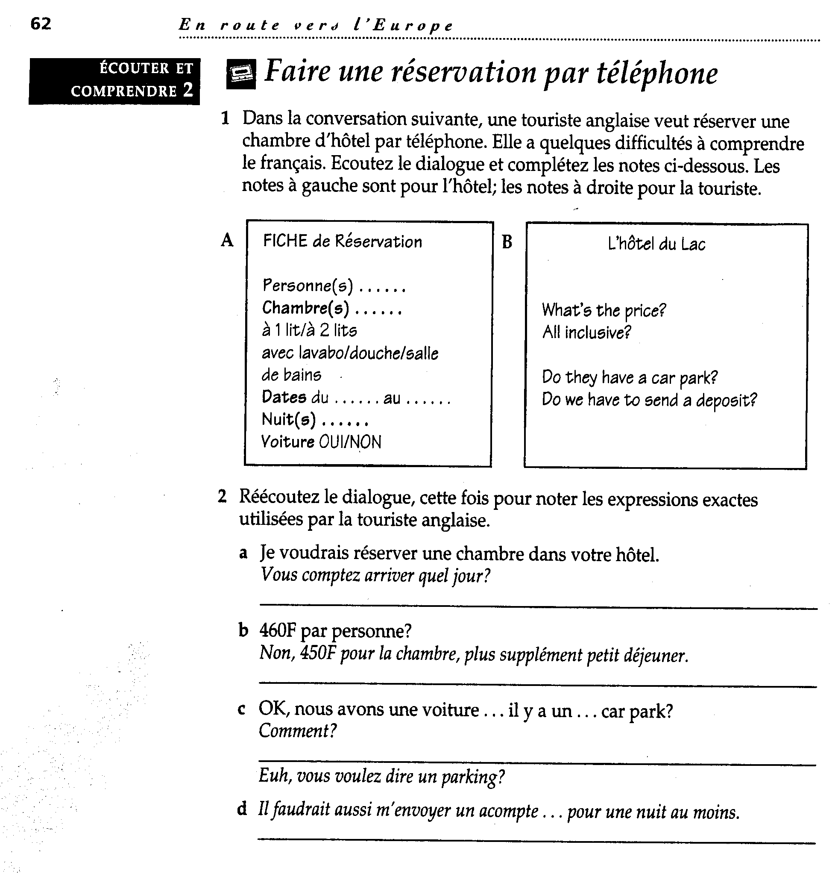

Appendix 2

Scanned text: ‘Manifestations 6’ (from Télé-textes 6A)

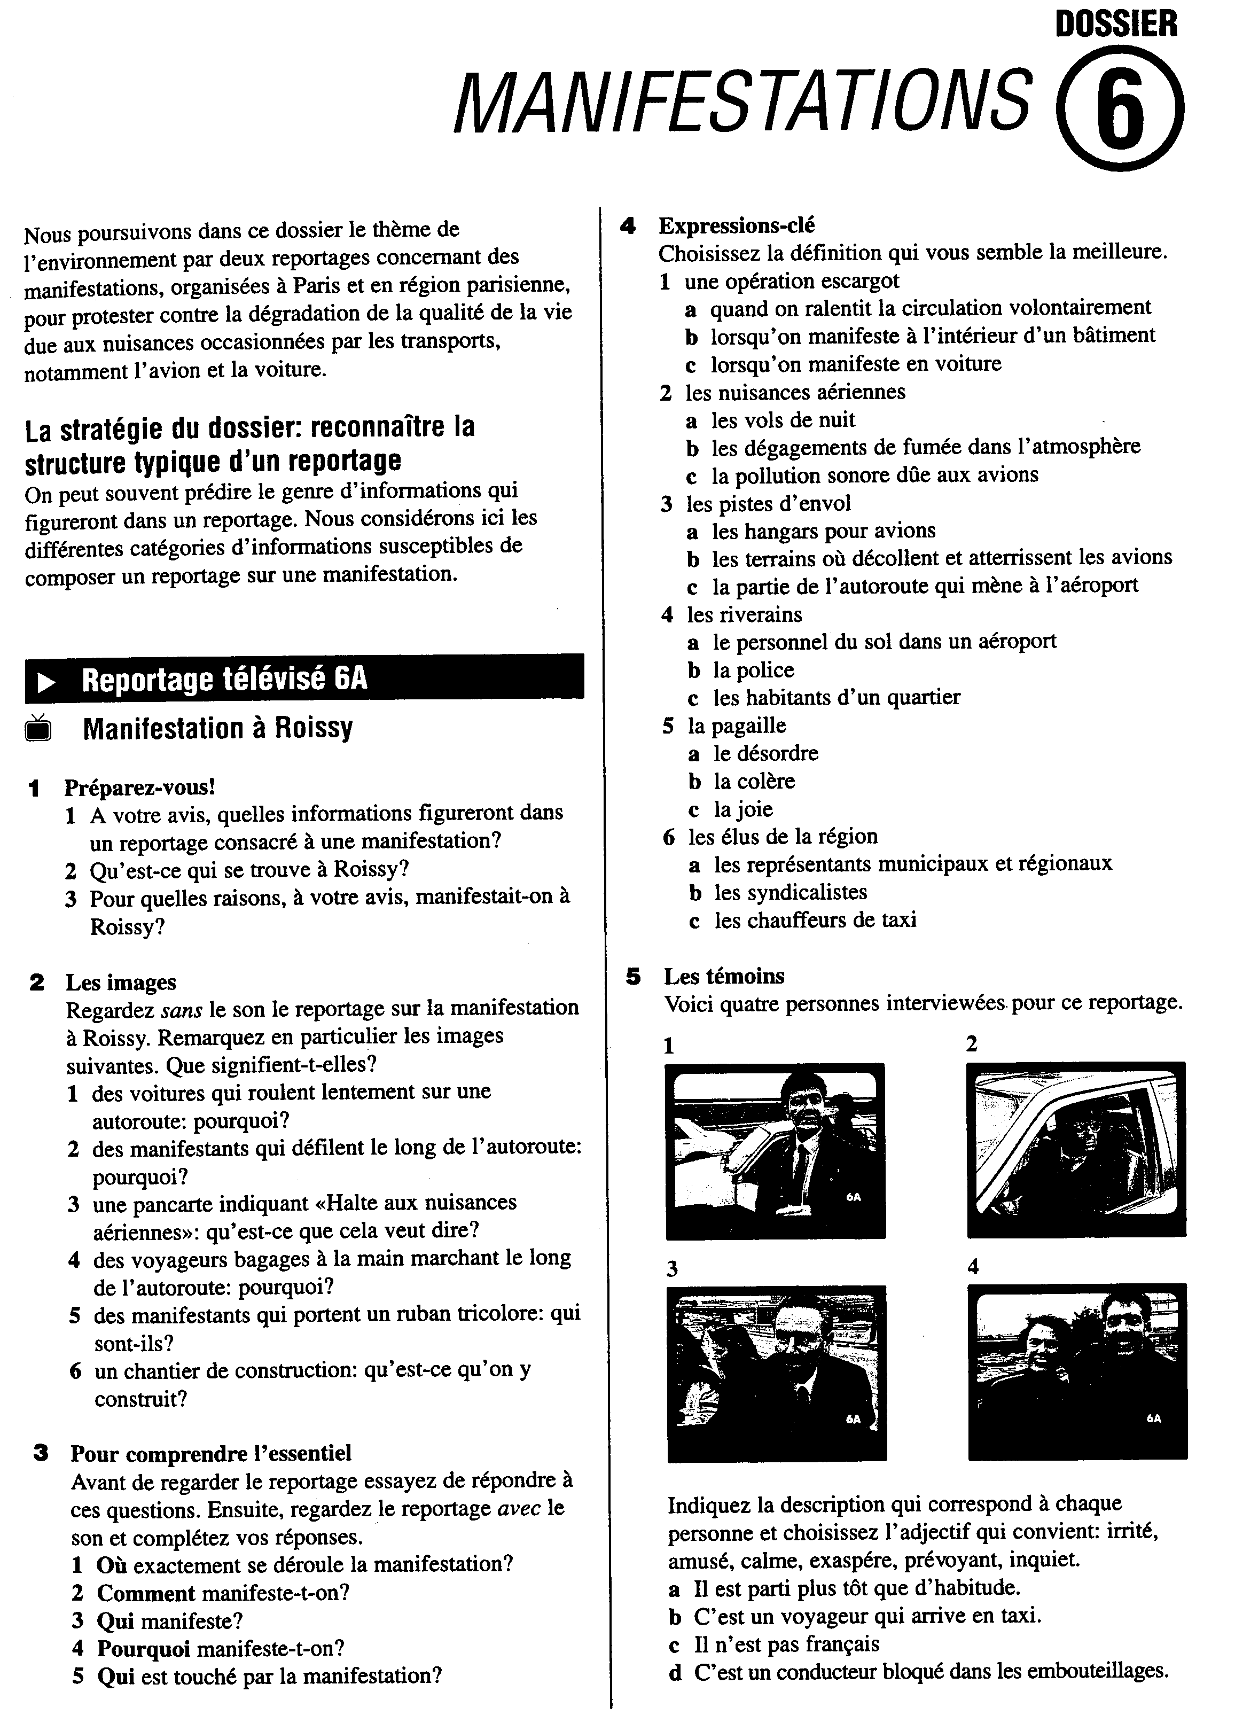

Appendix 3

Video dialogue
Extract from Lagelands by Miranda van Rossum, Roel Vismans, Agaath de Vries, © University of Hull, 2001. Reproduced with permission.

6.5 Toch maar naar de dokter
After a meal together, Kenny, Sara and Alan (students who share a flat) wake up feeling terrible. They think it might be ‘flu or foodpoisoning. They phone the doctor and leave a message, asking him to call them back. A few hours later, the doctor hasn’t rung back yet. They all still feel awful and decide that somebody will have to go and see the doctor in person.

Kenny Heeft die dokter nu nog niet gebeld? Ik voel me nog steeds niet goed.
Sara Nee, helaas niet. Misschien dat er toch maar even iemand naar de dokter moet.
Alan Nou, ik voel me al een beetje beter, dus zal ik dan maar gaan?
Sara Ja, alsjebelieft.

Bij de dokter

Dokter Dag, meneer Burton. Wat zijn de klachten?
Alan Nou, ik ben misselijk, ik heb buikpijn en ook een beetje koorts, denk ik. Mijn vrienden hebben er ook last van. Eén van hen denkt dat het misschien voedselvergiftinging is.
Dokter U heeft ook koorts, zei u?
Alan Ja
Dokter Dan is het waarschijnlijk geen voedselvergiftinging, maar buikgriep. Dat heerst. U kunt het beste in bed bleijven, en veen drinken. Il zal u iets voorschrijven voor de misselijkheid. (Hij schrijft een receptje uit)
Alstublieft. Drie maal daags één tablet. Innemen met water. Als het over drie dagen nog niet over is, dan even terugkomen.
Dankuwel, Dokter. Tot ziens.
Dokter Dag, en het beste

English translation

Off to the doctor’s

Kenny Hasn’t the doctor rung back yet?
Sara No, unfortunately he hasn’t. Perhaps somebody’s going to have to go to see the doctor.
Alan Well, I’m feeling a bit better, so shall I go?
Sara Yes, please.

At the doctor’s.

Docter Hello, Mr. Burton. What seems to be the problem?
Alan Well, I’m feeling sick, I have a stomach ache and also a bit of a temperature, I think. My friends are also suffering from the same thing. One of them thinks that it might be food poisoning.
Docter You said that you have also a temperature?
Alan Yes.
Docter Then it seems less likely to be food-poisoning than gastric ‘flu. There’s a lot of it around. You should stay in bed and drink a lot. I’ll prescribe something for your nausea. (He writes out a prescription.)
Here we are. One tablet three times daily. To be taken with a glass of water. If it’s not better after three days, then come back.
Alan Thank-you, Doctor. ‘Bye.
Docter Good bye. All the best.

Appendix 4

Scanned text: ‘La capa de ozono’ (from Tele con textos)

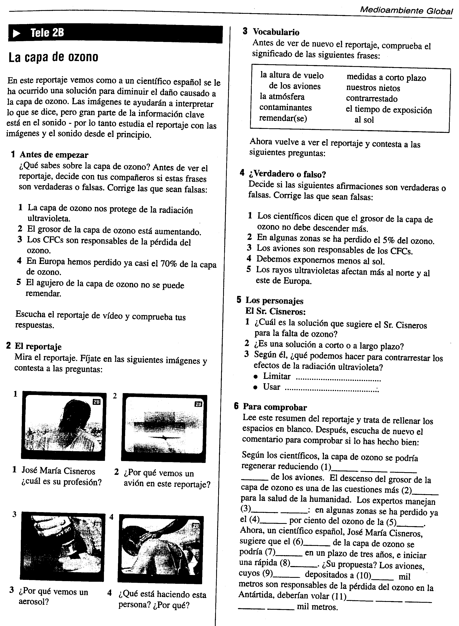

Appendix 5

Dialogue 1
Extract from Colloquial French by Alan Moys. Published by Routledge (1996). © Alan Moys 1996. Reproduced with permission.

Bob and Sylvia Hawkins are American tourists staying in a small French seaside town. They ask the hotel receptionist for information about places in the town.

BOB Pardon, monsieur. Nous voulons visiter le château. C'est loin?
RECEPTION Le château? Ah non, monsieur, c'est à dix minutes à pied. Voici un plan de la ville. Nous sommes ici, à l'Hôtel Miramar. Pour aller au château, vous tournez à gauche en sortant de l'hôtel; vous prenez la troisième rue à gauche puis la deuxième à droite, et l'entrée du château est à votre gauche, en face de la mairie.
BOB Pardon, vous pouvez parler plus lentement, je ne comprends pas.
RECEPTION You wish me to speak English?
SYLVIA Non, non, monsieur, ce n'est pas nécessaire, nous avons compris! Et pour la gare routière, s'il vous plaît?
RECEPTION La gare routière, madame? Regardons le plan. Voilà la gare routière. En sortant du château, vous tournez à votre droite, vous continuez tout droit et c'est à gauche, après le théâtre municipal. Tenez, vous pouvez garder le plan, c'est gratuit.
SYLVIA Merci beaucoup.
RECEPTION Je vous en prie. Bonne promenade, monsieur'dame!

English translation

BOB Excuse me. We want to visit the castle. Is it far?
RECEPTION The castle? Oh no, it’s ten minutes on foot. Here’s a town map. We are here, at the Hotel Miramar. To get to the castle, you turn left as you go out of the hotel. You take the third road on the left, then the second on the right, and the entrance to the castle is on your left, opposite the Town Hall.
BOB Sorry, could you speak more slowly. I don’t understand.
RECEPTION You wish me to speak English?
SYLVIA No, no, that’s not necessary, we’ve understood! And what about the bus station?
RECEPTION The bus station? Let’s take a look at the map. Here’s the bus station. As you go out of the castle, you turn right, then straight on and it’s on the left, after the town theatre. Here you are ... you can keep the map. It’s free.
SYLVIA Thanks very much.
RECEPTION You’re welcome. Enjoy your walk.

Dialogue 2
Extract from Breakthrough 3 by Stephanie Rybak. Published by Palgrave Macmillan (1999). © Stephanie Rybak and Brian Hill 1989. Reproduced with permission.

Comment sortir de Paris?

Mme Kruc Tenez - voilà votre contrat, vos clés. Je vous ai inscrit sur le contrat comment vous rendre au parking, hein - vous n'avez qu'à suivre les flèches Hertz jaunes et noires - et je vous ai indiqué où se trouvait la voiture: deuxième sous-sol, place 353.
Dominique Je vous remercie. Pouvez-vous aussi avoir la gentillesse de m'indiquer comment sortir de Paris en évitant les embouteillages à cette heure-ci?
Mme Kruc Oui, bien sûr. Alors, c'est très simple: vous prenez l'avenue du Maine, jusqu'au bout, puis l'avenue du Général Leclerc, jusqu'au bout. Ensuite, vous prenez le périphérique est, et vous sortez autoroute A4.
Dominique C'est donc bien la direction de Strasbourg. Auriez-vous une carte de France?
Mme Kruc Ah oui, bien sûr. Tenez.
Dominique Je vous remercie.
Mme Kruc Je vous en prie.
Dominique Au revoir.
Mme Kruc Au revoir, Madame - bonne route!

English translation

Mme Kruc There you go - there’s your contract, your keys. I’ve noted down on the contract how to get to the parking, OK? - just follow the yellow and black Hertz arrows - and I’ve indicated where the car is, second basement, space 353
Dominique Thanks very much. Would you also be kind enough to show me how to get out of Paris at this time of day without running into traffic jams?
Mme Kruc Yes, of course. So, it’s really easy: you take l'avenue du Maine right to the end, then l'avenue du Général Leclerc, right to the end. Then, you take the Ring road east and you get off onto the autoroute A4.
Dominique And that’s definitely the direction to Strasbourg, is it? Would you have a map of France?
Mme Kruc Oh yes, of course. Here you are.
Dominique Thanks.
Mme Kruc You’re welcome.
Dominique Goodbye.
Mme Kruc ‘Bye and have a safe journey!

Appendix 6

Scanned text: ‘Tourisme 2’ (from Télé-textes)

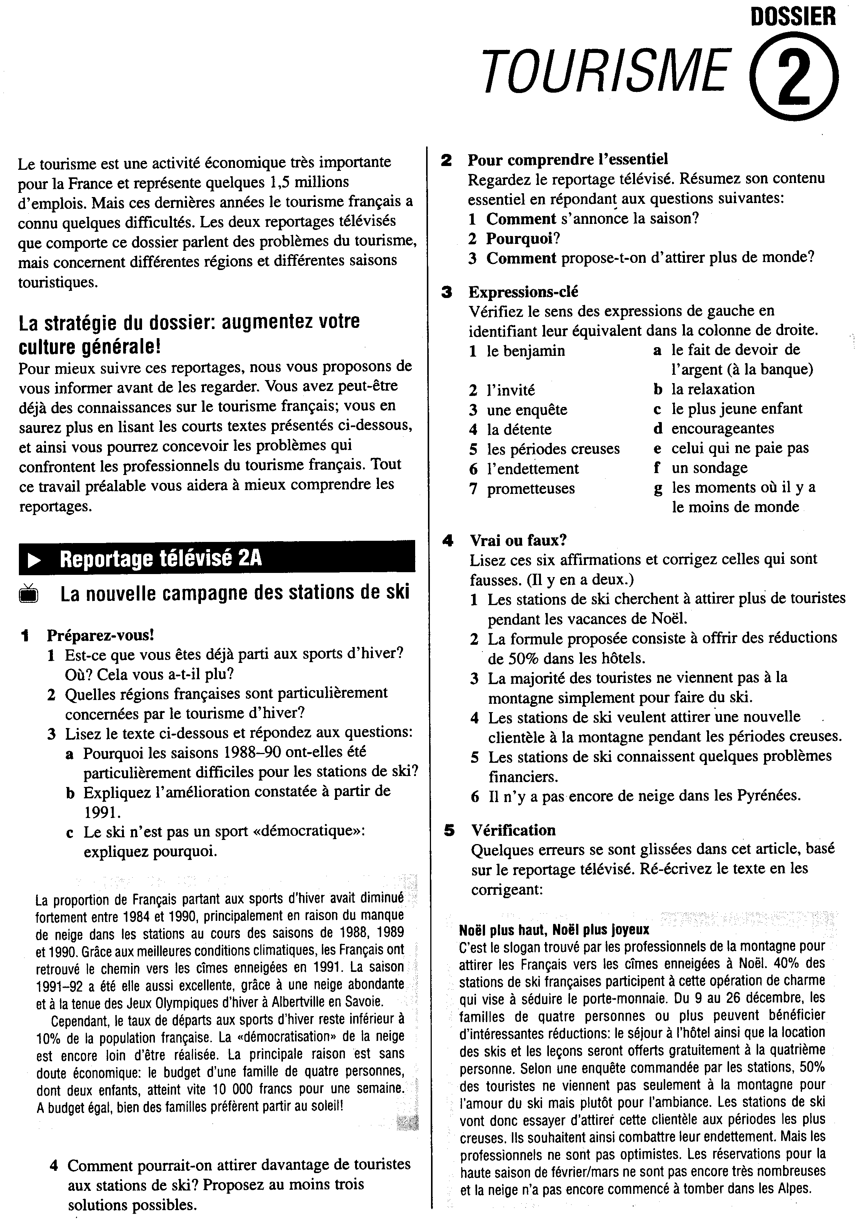

Appendix 7

Scanned text: ‘Conversation dans un train’ (from En route vers l’Europe, Unit 1, ex. 1)
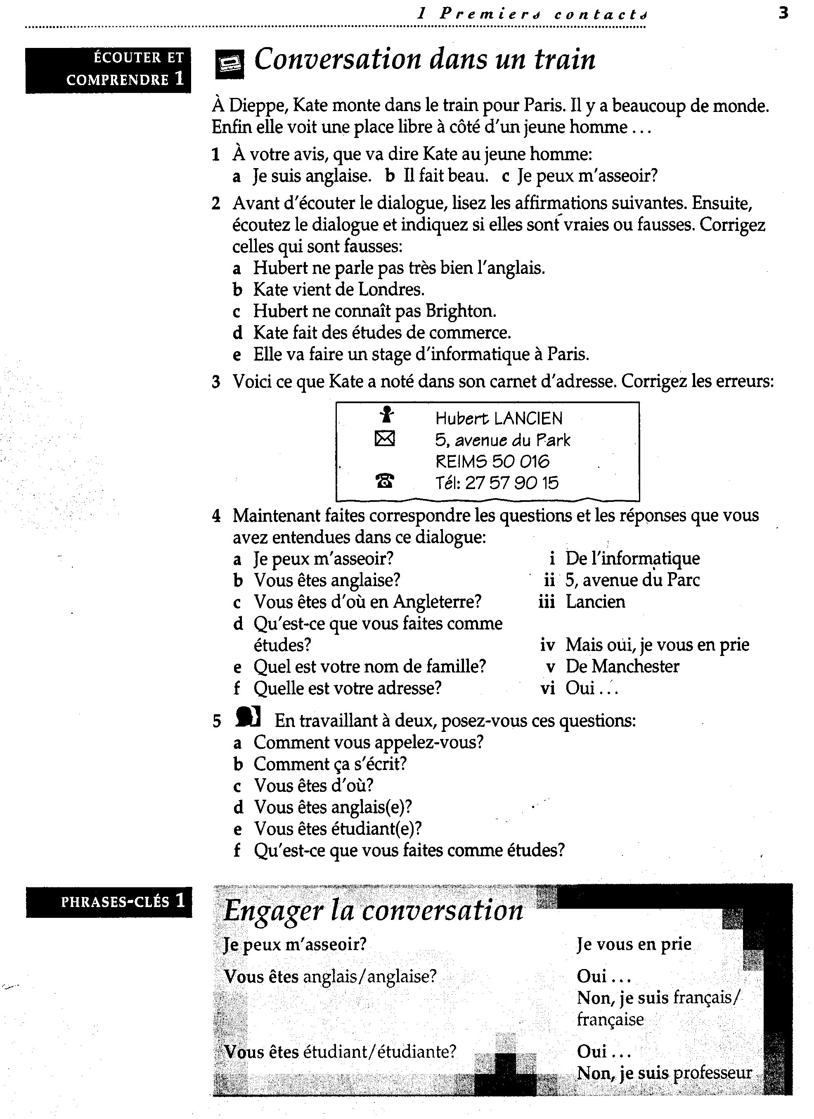

Appendix 8

Scanned text: ‘Réportage télévisé 4C’ (from Télé-textes)

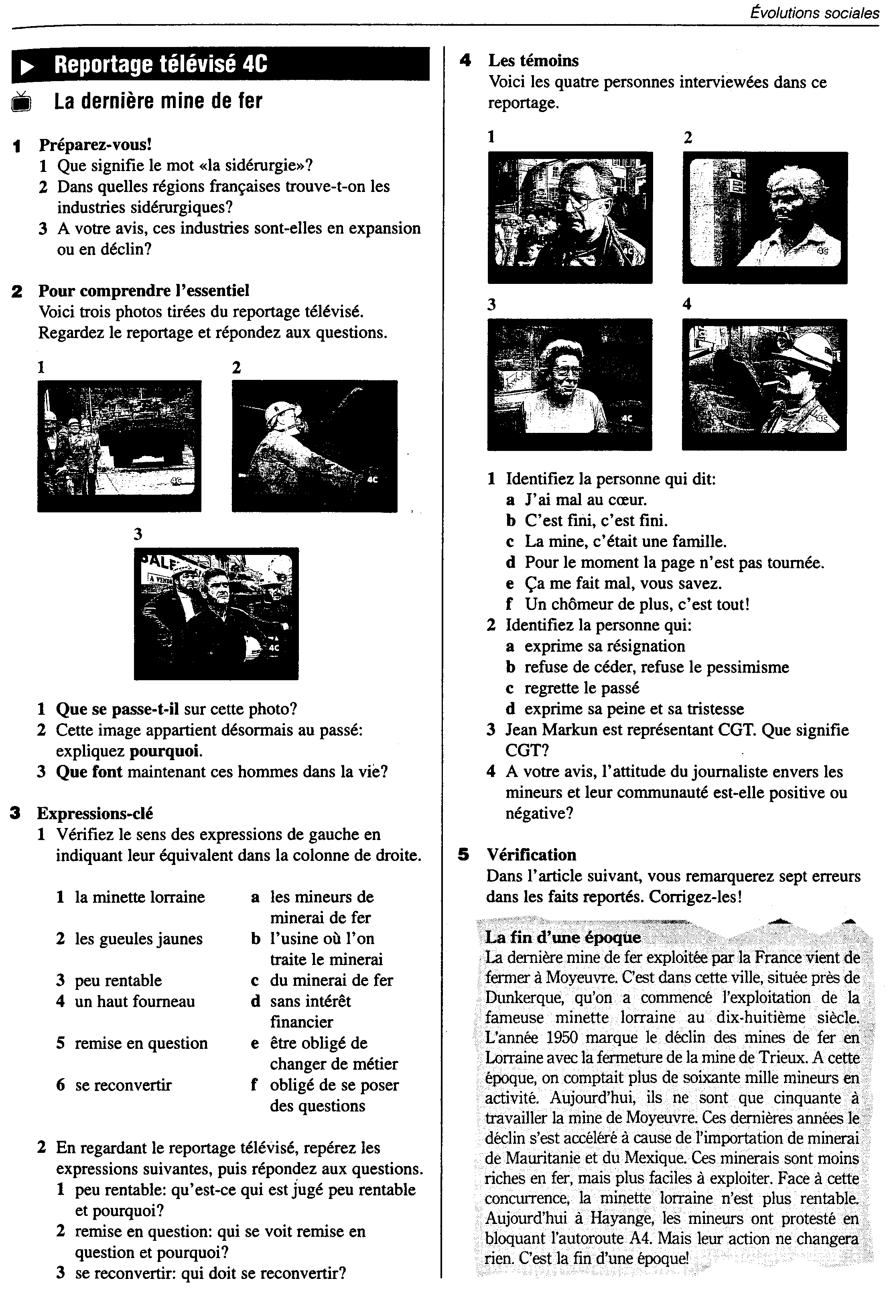

5.7 References

Bartlett, F C (1932) Remembering: A study in experimental and social psychology, Cambridge University Press, Cambridge
Borrás, I and Lafayette, R (1994) Effects of multimedia courseware subtitling on speaking performance of college students, The Modern Language Journal, 78 (1), 61–75
Brett, P (1995) Multimedia for listening comprehension: The design of a multimedia-based resource for developing listening skills, System, 23 (1), 77–-85
Brown, G, Anderson, A, Shillcock, R and Yule, G (1984) Teaching Talk, Cambridge University Press, Cambridge
Buck, G. (1999) Comprehension: Theory to Practice, Available at: http://www.englishlistening.com/theory.phtml [accessed 1/7/02]
Chaudron, C and Richards, J (1986) The effect of discourse markers on the comprehension of lectures, Applied Linguistics, 6, 45–59
Clarke, D F (1989) Communicative theory and its influence on materials production, Language Teaching, 22 (2), 73–86
Danan, M (1992) Reversed sub-titling and dual coding theory: new directions for foreign language instruction, Language Learning, 42 (4), 497–527
Field, J (1998) Skills and strategies: towards a new methodology for listening, English Language Teaching Journal, 52 (2), 110–18
Garza, T (1991) Evaluating the use of captioned video materials in advanced language learning, Foreign Language Annals, 24 (3), 239–58
Herron, C (1994) An investigation of the effectiveness of using an advance organizer to introduce video in the foreign language classroom, The Modern Language Journal, 78 (3), 190–98
Herron, C, Hanley, J E B and Cole, S P (1995) A comparison study of two advance organizers for introducing beginning foreign language students to video, The Modern Language Journal, 79 (3), 387–95
Hoven, D (1999) A model for listening and viewing comprehension in multimedia environments, Language Learning and Technology, 3 (1), 88–103. Available at http://polyglot.cal.msu.edu/llt/vol3num1/hoven/index.html [accessed 21/12/99]
Krashen, S (1985) The input hypothesis, Longman, Harlow
Long D R, (1990) What you don’t know can’t help you: an exploratory study of background knowledge and second language listening comprehension, Studies in Second Language Acquisition, 12, 65–80
Long, M (1983) Native speaker/non-native speaker conversation and the negotiation of comprehensible input, Applied Linguistics, 4, 126–41
Mueller, G (1980) Visual contextual cues and listening comprehension: an experiment, The Modern Language Journal, 64 (3), 335–40
Nunan, D (1991) Language Teaching Methodology, Prentice Hall, London
O'Malley, J M, Chamot, A U and Kupper, L (1989) Listening comprehension strategies in second language acquisition, Applied Linguistics, 10 (4), 418–36
Pica, T. (1994) Research on negotiation: what does it reveal about second language learning conditions, processes and outcomes? Language Learning, 44, 493–527
Pica, T, Young, R and Doughty, C (1987) The impact of interaction on comprehension, TESOL Quarterly, 21, 737–58
Rost, M (2002) Teaching and Researching Listening, Pearson Education, Harlow
Schmidt, R (1990) The role of consciousness in second language learning’ in Applied Linguistics, 11, 17–46
Secules T, Herron, C and Tomasello, M. (1992) The effect of video context on foreign language learning, The Modern Language Journal, 76 (4), 480–90
Skehan, P (1998) A Cognitive Approach to Language Learning, Oxford University Press, Oxford
Tudor, I. and Tuffs, R. (1991) Formal and content schema activation in L2 viewing comprehension, RELC Journal, 22 (2),79–97
Vanderplank, R (1988) The value of tele-text subtitles in language learning, English Language Teaching Journal, 42, 272–81
VanPatten B (1989) Can learners attend to form and content while processing input? Hispania, 72, 409–17
Wajnryb, R (1990) Grammar Dictation, Oxford University Press, Oxford
Weissenreider, M (1987) Listening to the news in Spanish, The Modern Language Journal, 71 (1), 18–27

Course materials referred to
Broady, E and Carpenter, C (1996) En route vers l’Europe: French for life, work and study, Hodder and Stoughton, London. Coursebook for post-GCSE university learners of French, with two C60 audio cassette and support book for teachers.
Broady, E and Meinhof, U (1995) Télé-textes, Oxford University Press, Oxford. Cahier d’activités for A-level learners + of French. 60 minute video cassette. CD-ROM published by Wild Strawberry.
Broady, E and Shade, M (1996) Tele con textos, Oxford University Press, Oxford. Libro de actividades for A-level learners + of Spanish. 60 minute video cassette. CD-ROM published by Wild Strawberry.
Dominique, P, Demari, J, Grellier, D, Lemoine, A and Plum, C (1984) Sans Frontières 3. Clé International, Paris. Coursebook and audio cassettes for advanced-level learners of French.
Moys, A (1996) Colloquial French, Routledge, London. Coursebook for self-study learners of French, with two 60 audio cassettes.
Rybak, S (1999) Breakthrough French 3, Palgrave Macmillan, London. Coursebook for post-beginner self-study learners of French, with audio cassettes.
van Rossum, M, Vismans, R and de Vries, A (2001) Lagelands. University of Hull. Distance learning package for beginners of Dutch. Coursebook, Video CD and web-site.

5.8 Recommended further reading

On listening
Anderson A and Lynch, T (1988) Listening, Oxford University Press, Oxford
Written for EFL teacher education. Covers both theory and practice through a
series of tasks. Useful activities for workshops.

Nunan, D (1997), Listening in language learning, in The Language Teacher Online, 1 (2), available at http://langue.hyper.chubu.ac.jp/jalt/pub/tlt/97/sep/nunan.html
[accessed 11/9/00]

A clear and easily accessible presentation of basic principles.

Rost, M (1998) Listening in Language Learning, 5th edn, Longman, Harlow
Comprehensive, covering theory and practice in great detail. The approach is academic, with extensive reference to current research.

Rost, M (2002) Teaching and Researching Listening, Pearson Education,
Harlow
The definitive book on listening in second language teaching and learning, providing clear theoretical explanations and implications for practice. Lots of grids and checklists provide useful analytic tools. A section on 'Listening Research Projects' provides inspiration for would-be classroom researchers.

On video
Allen, M (1985) Teaching English with Video, Longman, Harlow
A comprehensive guide to using video, with useful lesson plans and lots of examples.

Fawkes, S (1998) Switched on? Video resources in modern language settings, Multilingual Matters, Clevedon
A very practical book, providing useful checklists for modern language teachers wanting to exploit video recordings

On digital technologies for listening
Brett, P (1995) Multimedia for listening comprehension: The design of a multimedia-based resource for developing listening skills, System, 23 (1), 77–85
Report on the design of a video-based CD ROM for teaching English for Business. The insights are of interest to all language teachers.

Hoven, D (1999) A model for listening and viewing comprehension in multimedia environments, Language Learning and Technology, 3 (1), 88–103 Available at http://polyglot.cal.msu.edu/llt/vol3num1/hoven/index.html [accessed 21/12/99]
A useful overview of the theoretical and design issues involved in supporting listening activities in a self-access digital environment.

5.9 Assessment task

Choose an audio or video recording that will be suitable for a group you are teaching and develop a cycle of activities to exploit it.

1. Referring to the concepts outlined in Section 5.2, describe the characteristics of the input you have chosen.

2. Referring to the principles established in Section 5.3, design a cycle of activities to exploit your chosen input.

3. Implement your listening activities with your group of target students. Then reflect on the effectiveness of your activities. In particular, consider what your students found easy and difficult, and what strategies they used in completing the activities. How could you address any problems in a revision of the materials?

